Enhanced Dopamine MSNs vs Others Epigenetic Analysis

Deepak Poduval

2025-08-25

## Load and Initial Data Exploration

# Load the RDS file  
so <- readRDS("raw_data/GSE167920_Results_full_nuclei_processed_final.rds")  
  
# Explore data structure  
cat("Data Overview\n")

## Data Overview

cat(paste("Number of cells:", ncol(so)), "\n")

## Number of cells: 63884

cat(paste("Number of genes:", nrow(so)), "\n")

## Number of genes: 2000

cat(paste("Available assays:", paste(names(so@assays), collapse = ", ")), "\n")

## Available assays: RNA, integrated

# Check metadata  
cat("Metadata Columns\n")

## Metadata Columns

print(colnames(so@meta.data))

## [1] "cell.id" "nFeatures_RNA" "nCount.RNA" "percent.ribo"   
## [5] "seurat_clusters" "region_name" "cell_type" "cell_type_2"   
## [9] "monkey"

# Check cell types  
if ("cell_type" %in% colnames(so@meta.data)) {  
 cat("Cell Type Distribution\n")  
 print(table(so@meta.data$cell_type))  
}

## Cell Type Distribution  
##   
## Oligos Astrocytes DRD2 DRD1   
## 14314 17424 7310 9148   
## Interneurons Oligos_Pre Microglia Endothelial   
## 7629 3079 2430 1723   
## Mural/Fibroblast Unknown1 Unknown2 Unknown3   
## 827 0 0 0   
## Unknown4   
## 0

# Check for D1/D2 MSN populations  
cat("Checking For D1/D2 MSNs\n")

## Checking For D1/D2 MSNs

msn_types <- grep("DRD|D1|D2|MSN", unique(so@meta.data$cell_type), value = TRUE, ignore.case = TRUE)  
cat(paste("MSN-related cell types found:", paste(msn_types, collapse = ", ")), "\n")

## MSN-related cell types found: DRD1, DRD2

# Basic metadata structure  
str(so@meta.data, max.level = 1)

## 'data.frame': 63884 obs. of 9 variables:  
## $ cell.id : int 61609 61619 61620 61636 61661 61682 61718 61719 61720 61741 ...  
## $ nFeatures_RNA : int 5061 3604 3940 5650 5248 4431 5151 3452 3531 4684 ...  
## $ nCount.RNA : num 15884 8927 9198 20929 17577 ...  
## $ percent.ribo : num 0.00327 0.00493 0.00402 0.00253 0.00256 ...  
## $ seurat_clusters: Factor w/ 44 levels "0","1","2","3",..: 25 25 17 10 17 25 10 33 33 17 ...  
## $ region_name : Factor w/ 3 levels "caudate","nacc",..: 2 2 2 2 2 2 2 2 2 2 ...  
## $ cell_type : Factor w/ 13 levels "Oligos","Astrocytes",..: 4 4 4 4 4 4 4 4 4 4 ...  
## $ cell_type_2 : Factor w/ 8 levels "Oligos","Astrocytes",..: 3 3 3 3 3 3 3 3 3 3 ...  
## $ monkey : Factor w/ 2 levels "Monkey_F","Monkey_P": 1 1 1 1 1 1 1 1 1 1 ...

## Quality Control Assessment

# Clear any problematic graph objects first  
so@graphs <- list()  
  
# Calculate additional QC metrics if not present  
if (!"percent.mt" %in% colnames(so@meta.data)) {  
 so[["percent.mt"]] <- PercentageFeatureSet(so, pattern = "^MT-")  
}  
if (!"percent.ribo" %in% colnames(so@meta.data)) {  
 so[["percent.ribo"]] <- PercentageFeatureSet(so, pattern = "^RP[SL]")  
}  
  
# QC summaries  
summary(so@meta.data$nFeatures_RNA)

## Min. 1st Qu. Median Mean 3rd Qu. Max.   
## 1001 2074 2770 3209 4361 11404

summary(so@meta.data$nCount.RNA)

## Min. 1st Qu. Median Mean 3rd Qu. Max.   
## 926.6 2932.8 4681.0 7260.8 10068.0 110443.0

summary(so@meta.data$percent.ribo)

## Min. 1st Qu. Median Mean 3rd Qu. Max.   
## 0.000000 0.001516 0.002180 0.002383 0.002970 0.023988

# QC plots  
p1 <- VlnPlot(so, features = c("nFeatures_RNA", "nCount.RNA", "percent.ribo"), ncol = 3, pt.size = 0.1)  
print(p1)

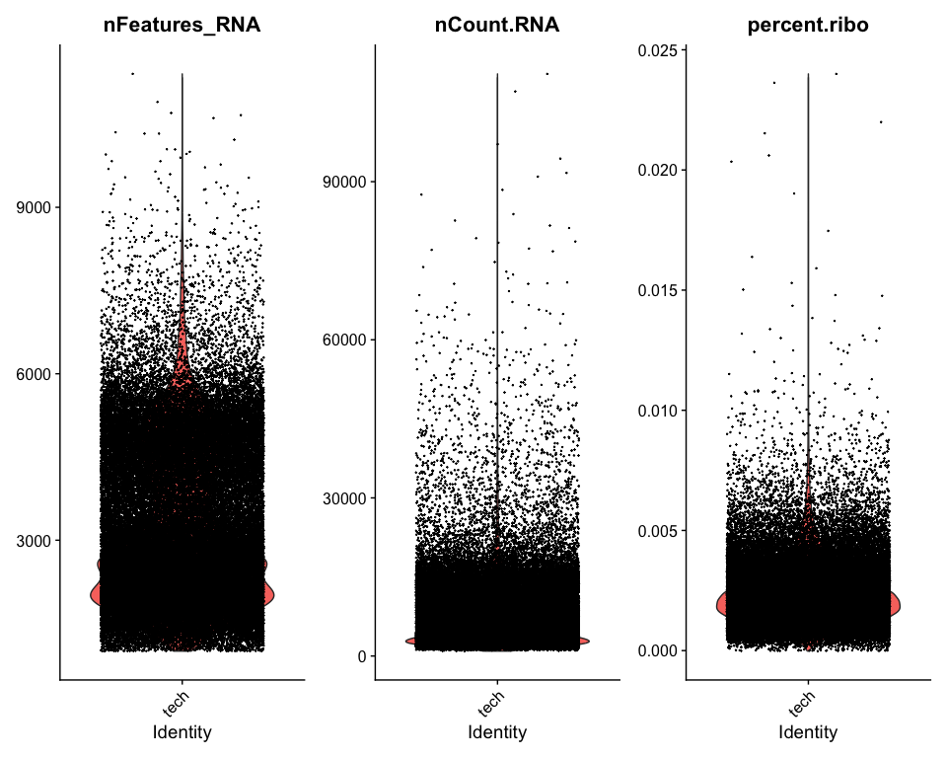

ggsave("MSNvsO_figures/QC_violin_plots.png", p1, width = 15, height = 6)  
  
p2 <- FeatureScatter(so, feature1 = "nCount.RNA", feature2 = "nFeatures_RNA") + geom_smooth(method = "lm")  
p3 <- FeatureScatter(so, feature1 = "nCount.RNA", feature2 = "percent.ribo") + geom_smooth(method = "lm")  
p4 <- p2 + p3  
print(p4)

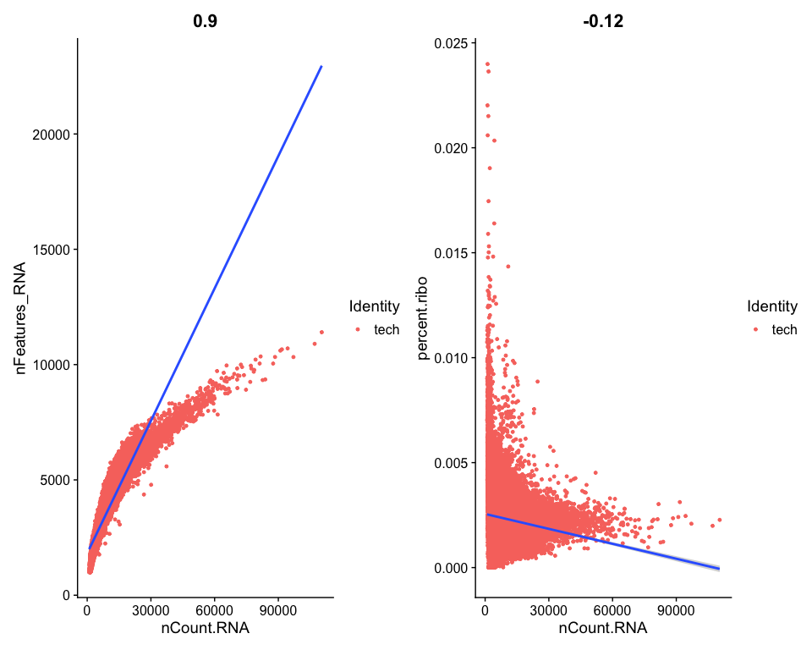

ggsave("MSNvsO_figures/QC_scatter_plots.png", p4, width = 12, height = 6)

## Data Filtering and Quality Control

cat("Before Filtering\n")

## Before Filtering

cat(paste("Cells:", ncol(so)), "\n")

## Cells: 63884

cat(paste("Genes:", nrow(so)), "\n")

## Genes: 2000

if ("cell_type" %in% colnames(so@meta.data)) {  
 cat("Cell Type Distribution Before Filtering\n")  
 print(table(so@meta.data$cell_type))  
}

## Cell Type Distribution Before Filtering  
##   
## Oligos Astrocytes DRD2 DRD1   
## 14314 17424 7310 9148   
## Interneurons Oligos_Pre Microglia Endothelial   
## 7629 3079 2430 1723   
## Mural/Fibroblast Unknown1 Unknown2 Unknown3   
## 827 0 0 0   
## Unknown4   
## 0

# Apply filtering based on QC metrics  
so <- subset(so, subset = nFeatures_RNA > 200 &  
 nFeatures_RNA < 8000 &  
 nCount.RNA > 1000 &  
 nCount.RNA < 80000 &  
 percent.ribo < 0.02)  
  
cat("After Filtering\n")

## After Filtering

cat(paste("Cells:", ncol(so)), "\n")

## Cells: 63683

cat(paste("Genes:", nrow(so)), "\n")

## Genes: 2000

if ("cell_type" %in% colnames(so@meta.data)) {  
 cat("Cell Type Distribution After Filtering\n")  
 print(table(so@meta.data$cell_type))  
}

## Cell Type Distribution After Filtering  
##   
## Oligos Astrocytes DRD2 DRD1   
## 14311 17422 7278 9117   
## Interneurons Oligos_Pre Microglia Endothelial   
## 7504 3078 2430 1716   
## Mural/Fibroblast   
## 827

## Data Normalization and Scaling

DefaultAssay(so) <- "RNA"  
  
# Normalize if needed  
if (is.null(so[["RNA"]]@data) || ncol(so[["RNA"]]@data) == 0) {  
 cat("Normalizing RNA data...\n")  
 so <- NormalizeData(so)  
} else {  
 cat("RNA data already normalized\n")  
}

## RNA data already normalized

# Variable features  
if (length(VariableFeatures(so)) == 0) {  
 cat("Finding variable features...\n")  
 so <- FindVariableFeatures(so, selection.method = "vst", nfeatures = 2000)  
} else {  
 cat("Variable features already identified\n")  
}

## Finding variable features...

# Plot variable features  
top10 <- head(VariableFeatures(so), 10)  
p5 <- VariableFeaturePlot(so)  
p6 <- LabelPoints(plot = p5, points = top10, repel = TRUE)  
print(p6)

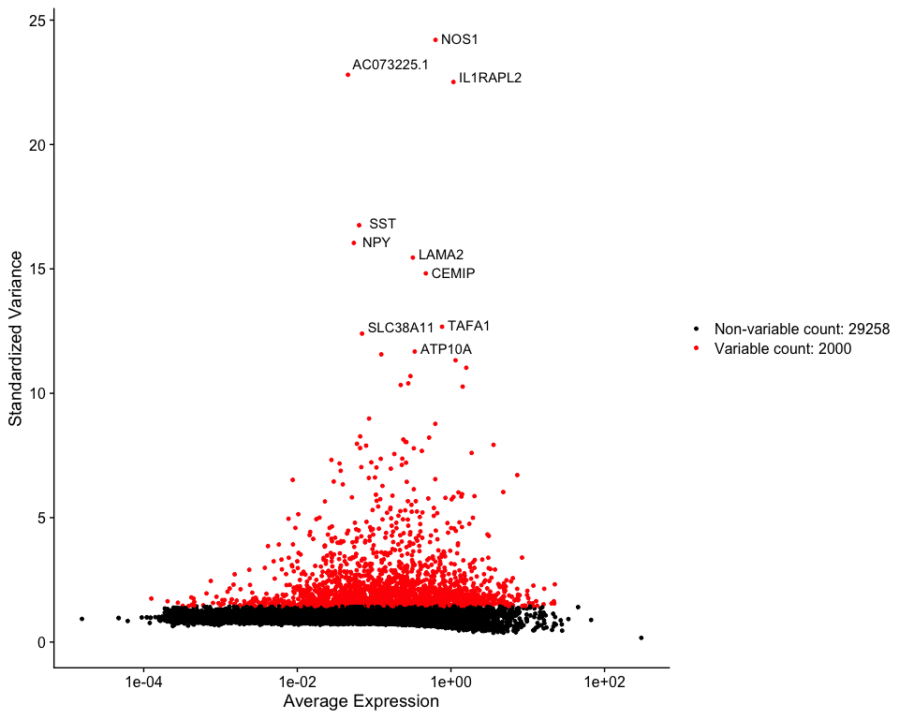

ggsave("MSNvsO_figures/Variable_Features.png", p6, width = 12, height = 8)  
  
# Scale only variable features for speed  
if (is.null(so[["RNA"]]@scale.data) || ncol(so[["RNA"]]@scale.data) == 0) {  
 cat("Scaling RNA variable features...\n")  
 so <- ScaleData(so, features = VariableFeatures(so))  
} else {  
 cat("RNA data already scaled\n")  
}

## Scaling RNA variable features...

## PCA and Dimensionality Reduction

if (!"pca" %in% names(so@reductions)) {  
 cat("Running PCA...\n")  
 so <- RunPCA(so, features = VariableFeatures(so))  
}  
  
p7 <- DimPlot(so, reduction = "pca", group.by = "cell_type", label = TRUE, repel = TRUE)  
print(p7)

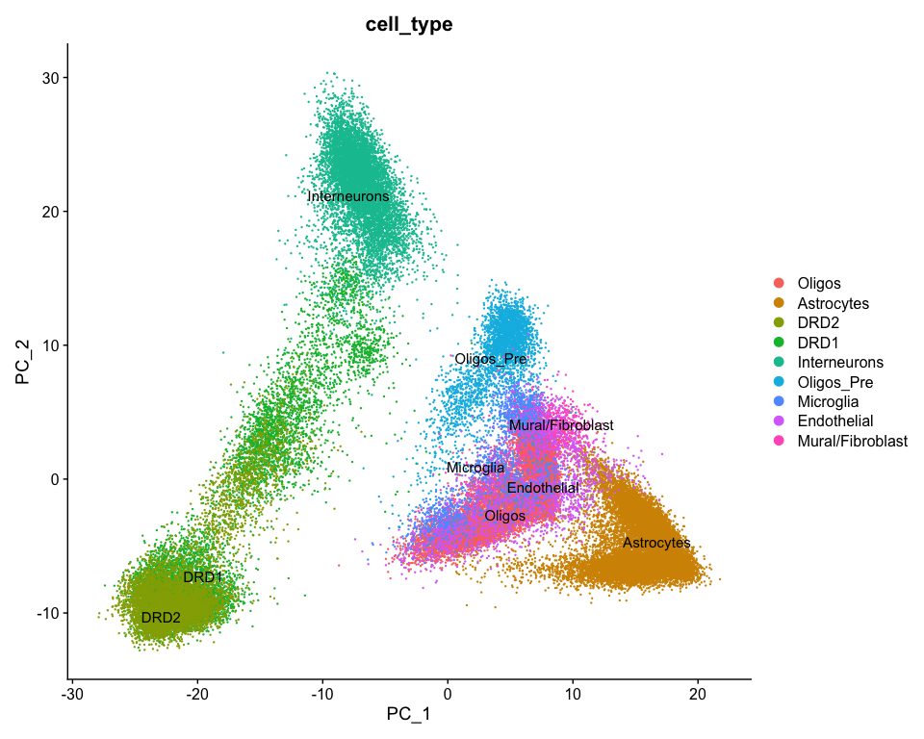

ggsave("MSNvsO_figures/PCA_plot.png", p7, width = 12, height = 8)  
  
p8 <- ElbowPlot(so, ndims = 50)  
print(p8)

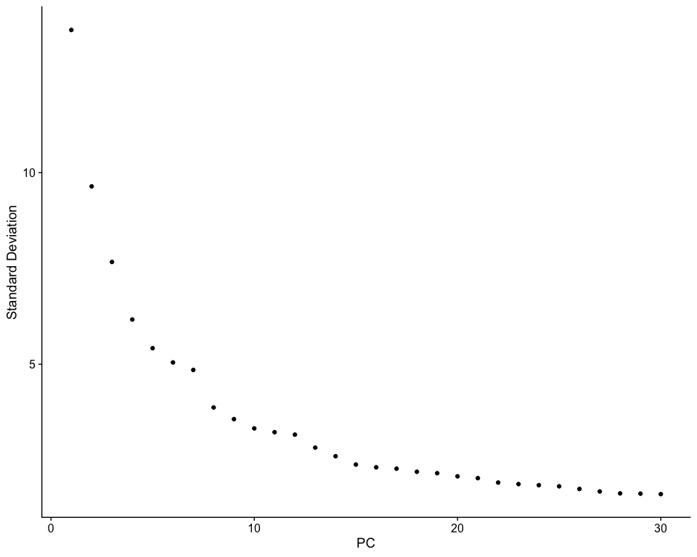

ggsave("MSNvsO_figures/Elbow_plot.png", p8, width = 10, height = 6)  
  
if (!"umap" %in% names(so@reductions)) {  
 cat("Running UMAP...\n")  
 set.seed(1234)  
 so <- RunUMAP(so, dims = 1:20)  
}  
  
p9 <- DimPlot(so, reduction = "umap", group.by = "cell_type", label = TRUE, repel = TRUE)  
print(p9)

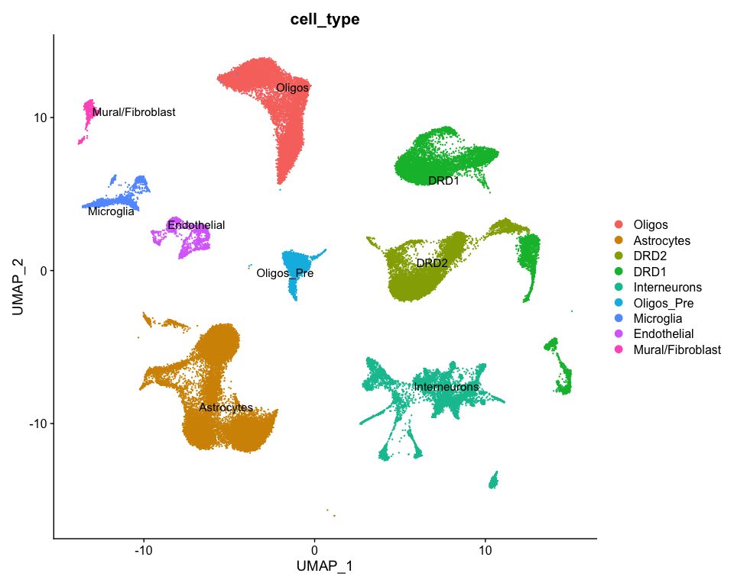

ggsave("MSNvsO_figures/UMAP_CellType.png", p9, width = 12, height = 10)

## Dopamine Receptor Expression Analysis and MSN Classification

# Key dopamine-related markers (filtered for reliably detected ones)  
dopamine_markers <- c("DRD1", "DRD2", "PPP1R1B", "PDE1B", "BCL11B", "KIAA1211L", "PDE2A", "SLIT3", "NGEF")  
  
present_markers <- dopamine_markers[dopamine_markers %in% rownames(so)]  
missing_markers <- setdiff(dopamine_markers, present_markers)  
  
cat("Dopamine Marker Availability\n")

## Dopamine Marker Availability

cat(paste("Present:", paste(present_markers, collapse = ", ")), "\n")

## Present: DRD1, DRD2, PPP1R1B, PDE1B, BCL11B, KIAA1211L, PDE2A, SLIT3, NGEF

cat(paste("Missing:", paste(missing_markers, collapse = ", ")), "\n")

## Missing:

if (length(present_markers) > 0) {  
 p10 <- FeaturePlot(so, features = present_markers, ncol = 3, reduction = "umap")  
 print(p10); ggsave("MSNvsO_figures/Dopamine_Markers_FeaturePlot.png", p10, width = 15, height = 10)  
  
 p11 <- VlnPlot(so, features = present_markers, group.by = "cell_type", ncol = 3, pt.size = 0)  
 print(p11); ggsave("MSNvsO_figures/Dopamine_Markers_ViolinPlot.png", p11, width = 15, height = 10)  
}

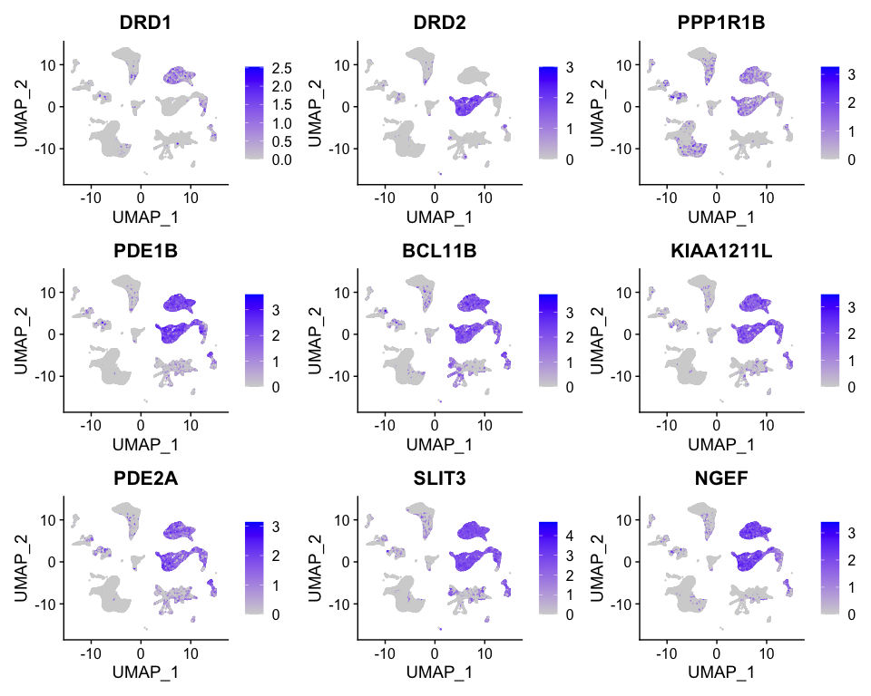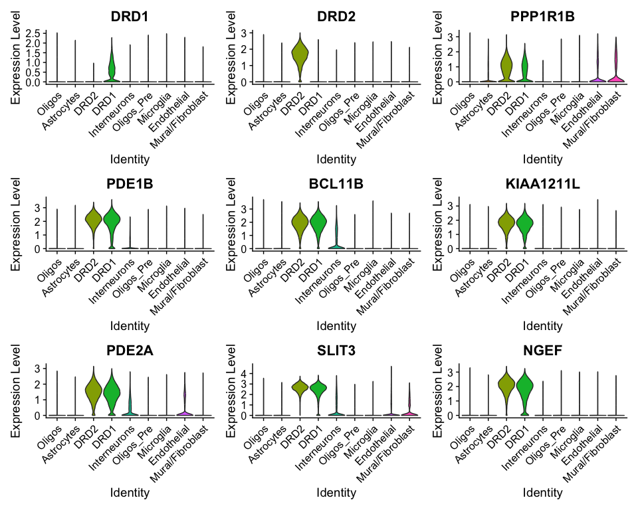

# D1/D2 classification and MSN vs Others grouping  
if (!"D1_D2_class" %in% colnames(so@meta.data) && all(c("DRD1","DRD2") %in% rownames(so))) {  
 drd1_exp <- GetAssayData(so, assay = "RNA", layer = "data")["DRD1", ]  
 drd2_exp <- GetAssayData(so, assay = "RNA", layer = "data")["DRD2", ]  
 so$D1_D2_class <- ifelse(drd1_exp > 1 & drd2_exp < 0.5, "D1R+",  
 ifelse(drd2_exp > 1 & drd1_exp < 0.5, "D2R+", "Mixed/Other"))  
 cat("D1R/D2R Classification\n"); print(table(so$D1_D2_class))  
}

## D1R/D2R Classification  
##   
## D1R+ D2R+ Mixed/Other   
## 2354 7378 53951

# Create MSN vs Others classification  
so$MSN_vs_Others <- "Others"  
  
# Method 1: Use cell_type annotation if available  
if ("cell_type" %in% colnames(so@meta.data)) {  
 msn_cell_types <- grep("DRD1|DRD2|MSN", unique(so@meta.data$cell_type), value = TRUE, ignore.case = TRUE)  
 if (length(msn_cell_types) > 0) {  
 so$MSN_vs_Others[so$cell_type %in% msn_cell_types] <- "MSNs"  
 cat("Using cell_type annotation for MSN identification\n")  
 cat("MSN cell types:", paste(msn_cell_types, collapse = ", "), "\n")  
 }  
}

## Using cell_type annotation for MSN identification  
## MSN cell types: DRD1, DRD2

# Method 2: Use D1/D2 classification as backup  
if (sum(so$MSN_vs_Others == "MSNs") == 0 && "D1_D2_class" %in% colnames(so@meta.data)) {  
 so$MSN_vs_Others[so$D1_D2_class %in% c("D1R+", "D2R+")] <- "MSNs"  
 cat("Using D1R+/D2R+ classification for MSN identification\n")  
}  
  
cat("MSN vs Others Classification\n")

## MSN vs Others Classification

print(table(so$MSN_vs_Others))

##   
## MSNs Others   
## 16395 47288

# Plot MSN vs Others classification  
p12 <- DimPlot(so, group.by = "MSN_vs_Others", reduction = "umap",  
 cols = c("MSNs" = "#FF6B6B", "Others" = "#4ECDC4"))  
print(p12); ggsave("MSNvsO_figures/MSN_vs_Others_Classification.png", p12, width = 10, height = 8)

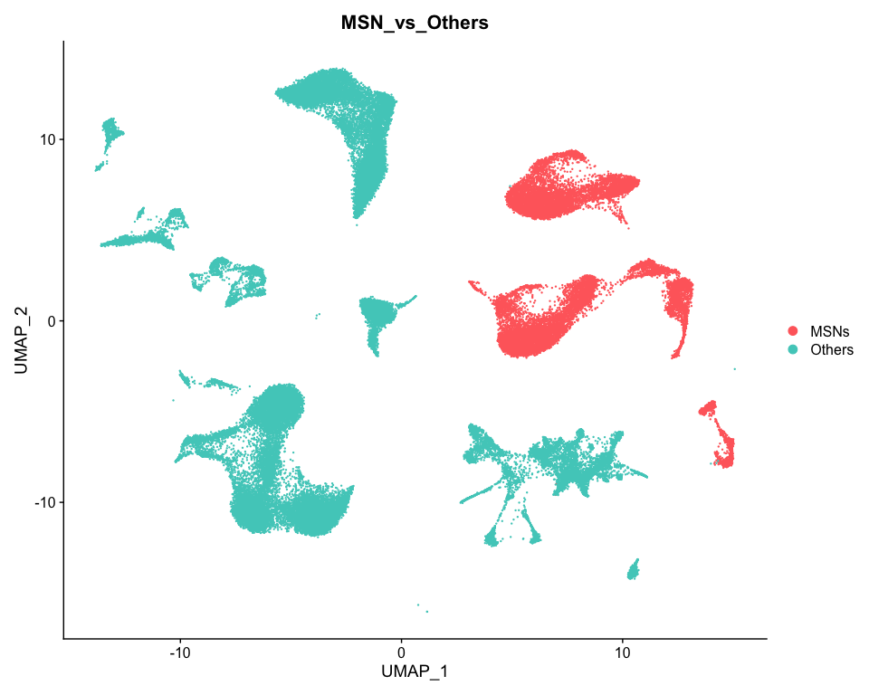

# Also plot D1/D2 within MSNs if available  
if ("D1_D2_class" %in% colnames(so@meta.data)) {  
 p12b <- DimPlot(so, group.by = "D1_D2_class", reduction = "umap",  
 cols = c("D1R+" = "#FF6B6B", "D2R+" = "#4ECDC4", "Mixed/Other" = "#95A5A6"))  
 print(p12b); ggsave("MSNvsO_figures/D1R_D2R_Classification.png", p12b, width = 10, height = 8)  
}

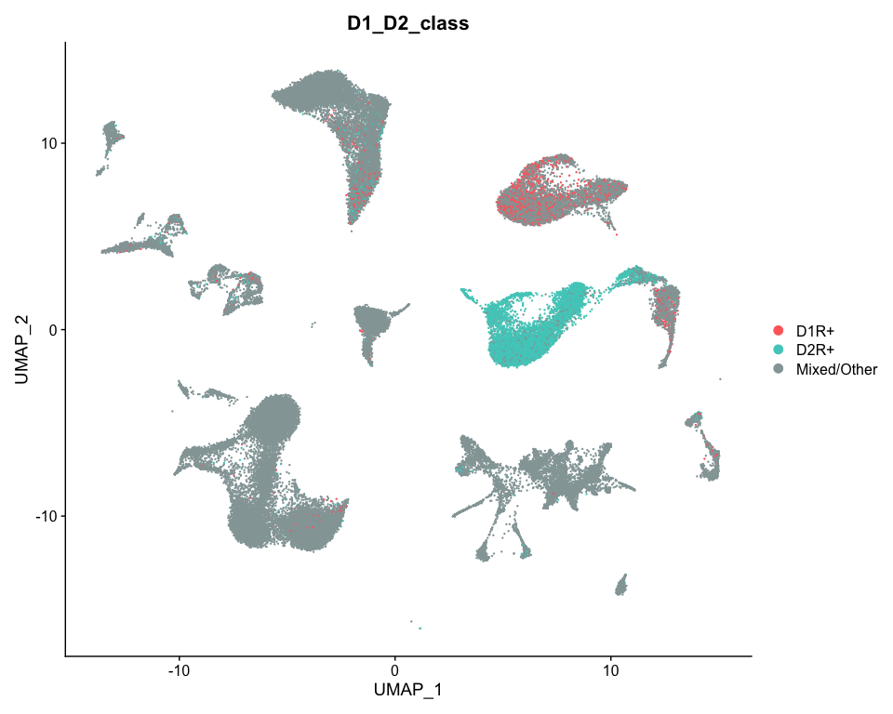

## Filter Dataset for Analysis

cat("Dataset Filtering for MSN vs Others Analysis\n")

## Dataset Filtering for MSN vs Others Analysis

# Filter out cells with too few genes/counts for robust analysis  
so_filtered <- so  
  
# Remove any cells that couldn't be classified  
so_filtered <- subset(so_filtered, subset = MSN_vs_Others %in% c("MSNs", "Others"))  
  
cat("Filtered Dataset Summary\n")

## Filtered Dataset Summary

cat(paste("Total cells:", ncol(so_filtered)), "\n")

## Total cells: 63683

cat(paste("Total genes:", nrow(so_filtered)), "\n")

## Total genes: 31258

print(table(so_filtered$MSN_vs_Others))

##   
## MSNs Others   
## 16395 47288

DefaultAssay(so_filtered) <- "RNA"  
  
# Filter low-expression genes  
non_zero_genes <- rownames(so_filtered)[Matrix::rowSums(GetAssayData(so_filtered, layer = "counts")) > 0]  
so_filtered <- subset(so_filtered, features = non_zero_genes)  
cat(paste("Genes after filtering:", nrow(so_filtered)), "\n")

## Genes after filtering: 31258

if (ncol(so_filtered) > 100) {  
 p13 <- DimPlot(so_filtered, reduction = "umap", group.by = "MSN_vs_Others", label = TRUE)  
 print(p13); ggsave("MSNvsO_figures/Filtered_Dataset_UMAP.png", p13, width = 10, height = 8)  
}

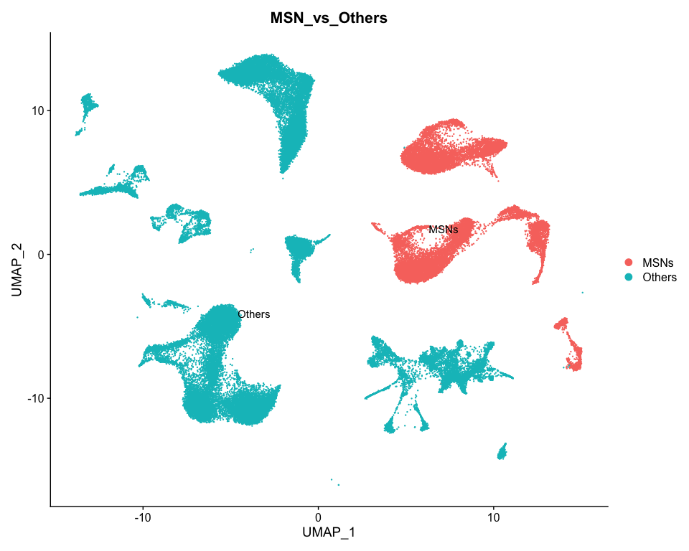

## Cell Type Composition Analysis

cat("Detailed Cell Type Composition Analysis\n")

## Detailed Cell Type Composition Analysis

# Cell type composition analysis  
if ("cell_type" %in% colnames(so_filtered@meta.data)) {  
 cell_composition <- so_filtered@meta.data %>%  
 group_by(MSN_vs_Others, cell_type) %>%  
 summarise(count = n(), .groups = "drop") %>%  
 group_by(MSN_vs_Others) %>%  
 mutate(percentage = count/sum(count) * 100)  
  
 # Visualize composition  
 p_composition <- ggplot(cell_composition, aes(x = MSN_vs_Others, y = percentage, fill = cell_type)) +  
 geom_bar(stat = "identity", position = "stack") +  
 labs(title = "Cell Type Composition: MSNs vs Others",  
 x = "Group", y = "Percentage", fill = "Cell Type") +  
 theme_minimal() +  
 theme(axis.text.x = element_text(angle = 45, hjust = 1))  
   
 print(p_composition)  
 ggsave("MSNvsO_figures/Cell_Type_Composition.png", p_composition, width = 12, height = 8)  
   
 # Save composition table  
 write.csv(cell_composition, "MSNvsO_tables/Cell_Type_Composition.csv", row.names = FALSE)  
 print(cell_composition)  
}

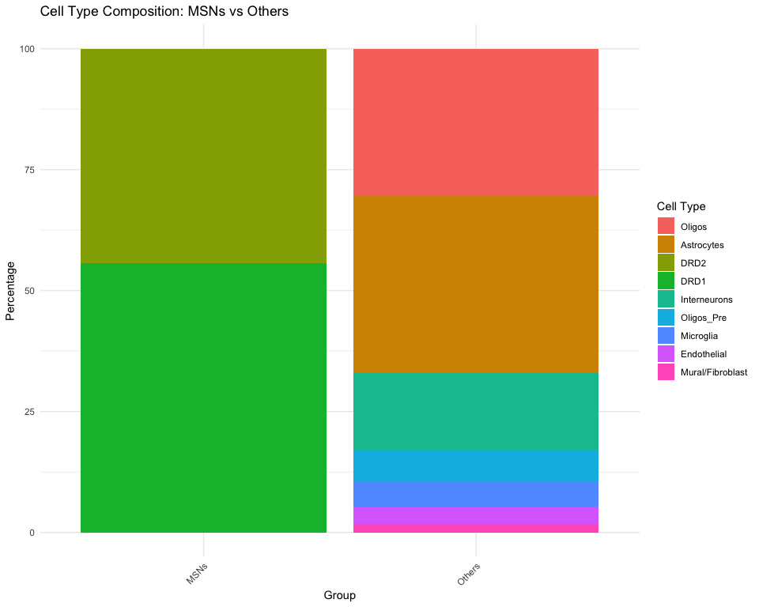

## # A tibble: 9 × 4  
## # Groups: MSN_vs_Others [2]  
## MSN_vs_Others cell_type count percentage  
## <chr> <fct> <int> <dbl>  
## 1 MSNs DRD2 7278 44.4   
## 2 MSNs DRD1 9117 55.6   
## 3 Others Oligos 14311 30.3   
## 4 Others Astrocytes 17422 36.8   
## 5 Others Interneurons 7504 15.9   
## 6 Others Oligos_Pre 3078 6.51  
## 7 Others Microglia 2430 5.14  
## 8 Others Endothelial 1716 3.63  
## 9 Others Mural/Fibroblast 827 1.75

# Quality metrics by group  
qc_by_group <- so_filtered@meta.data %>%  
 group_by(MSN_vs_Others) %>%  
 summarise(  
 mean_nFeatures = mean(nFeatures_RNA),  
 mean_nCounts = mean(nCount.RNA),  
 mean_percent_ribo = mean(percent.ribo),  
 median_nFeatures = median(nFeatures_RNA),  
 median_nCounts = median(nCount.RNA),  
 .groups = "drop"  
 )  
  
print(qc_by_group)

## # A tibble: 2 × 6  
## MSN_vs_Others mean_nFeatures mean_nCounts mean_percent_ribo median_nFeatures  
## <chr> <dbl> <dbl> <dbl> <dbl>  
## 1 MSNs 4607. 13001. 0.00256 4601  
## 2 Others 2703. 5069. 0.00232 2421  
## # ℹ 1 more variable: median_nCounts <dbl>

write.csv(qc_by_group, "MSNvsO_tables/QC_Metrics_by_Group.csv", row.names = FALSE)

## Enhanced Differential Expression Analysis

if (ncol(so_filtered) > 50) {  
 cat("Enhanced Differential Expression Analysis: MSNs vs Others\n")  
  
 Idents(so_filtered) <- so_filtered$MSN_vs_Others  
   
 cat("Comparing: MSNs vs Others\n")  
 print(table(Idents(so_filtered)))  
  
 # Run differential expression  
 markers_msn_vs_others <- FindMarkers(  
 so_filtered,  
 ident.1 = "MSNs",  
 ident.2 = "Others",  
 only.pos = FALSE,  
 min.pct = 0.1,  
 logfc.threshold = 0  
 )  
  
 markers_msn_vs_others$gene <- rownames(markers_msn_vs_others)  
  
 write.csv(markers_msn_vs_others, "MSNvsO_tables/DE_MSNs_vs_Others.csv", row.names = FALSE)  
  
 # Apply significance criteria  
 sc_sig <- markers_msn_vs_others %>%  
 filter(!is.na(p_val_adj)) %>%  
 filter(p_val_adj < 0.05, abs(avg_log2FC) > 1)  
  
 write.csv(sc_sig, "MSNvsO_tables/DE_MSNs_vs_Others_significant.csv", row.names = FALSE)  
  
 cat("Top Differential Genes (significant)\n")  
 print(head(sc_sig[order(sc_sig$p_val_adj), ], 10))  
  
 # Volcano plot  
 dfv <- markers_msn_vs_others %>%  
 mutate(  
 sig = ifelse(!is.na(p_val_adj) & p_val_adj < 0.05 & abs(avg_log2FC) > 1, "significant", "ns"),  
 log10_padj = -log10(p_val_adj + 1e-300),  
 dir = ifelse(avg_log2FC > 0, "MSNs enriched", "Others enriched")  
 )  
  
 p14 <- ggplot(dfv, aes(x = avg_log2FC, y = log10_padj)) +  
 geom_point(aes(alpha = sig == "significant", color = dir)) +  
 scale_alpha_manual(values = c("TRUE" = 1, "FALSE" = 0.3)) +  
 labs(x = "Average log2(Fold Change)", y = "-log10(Adjusted P-value)",  
 title = "MSNs vs Others - Differential Expression",  
 color = "Enriched in") +  
 theme_classic() +  
 geom_hline(yintercept = -log10(0.05), linetype = "dashed", alpha = 0.5) +  
 geom_vline(xintercept = c(-1, 1), linetype = "dashed", alpha = 0.5)  
   
 print(p14)  
 ggsave("MSNvsO_figures/Volcano_Plot_MSNs_vs_Others.png", p14, width = 12, height = 8)  
  
} else {  
 cat("Insufficient cells for differential expression analysis\n")  
}

## Enhanced Differential Expression Analysis: MSNs vs Others  
## Comparing: MSNs vs Others  
##   
## MSNs Others   
## 16395 47288   
## Top Differential Genes (significant)  
## p_val avg_log2FC pct.1 pct.2 p_val_adj gene  
## KIAA1211L 0 4.198860 0.980 0.108 0 KIAA1211L  
## PDE1B 0 4.954113 0.965 0.113 0 PDE1B  
## NGEF 0 4.389232 0.954 0.116 0 NGEF  
## BCL11B 0 3.917073 0.985 0.153 0 BCL11B  
## CA12 0 4.915865 0.882 0.056 0 CA12  
## CACNA1H 0 4.183185 0.899 0.074 0 CACNA1H  
## PDE2A 0 3.908405 0.957 0.135 0 PDE2A  
## PTPN5 0 4.228786 0.975 0.158 0 PTPN5  
## AC005906.2 0 3.832358 0.957 0.148 0 AC005906.2  
## TESC 0 4.579178 0.866 0.057 0 TESC

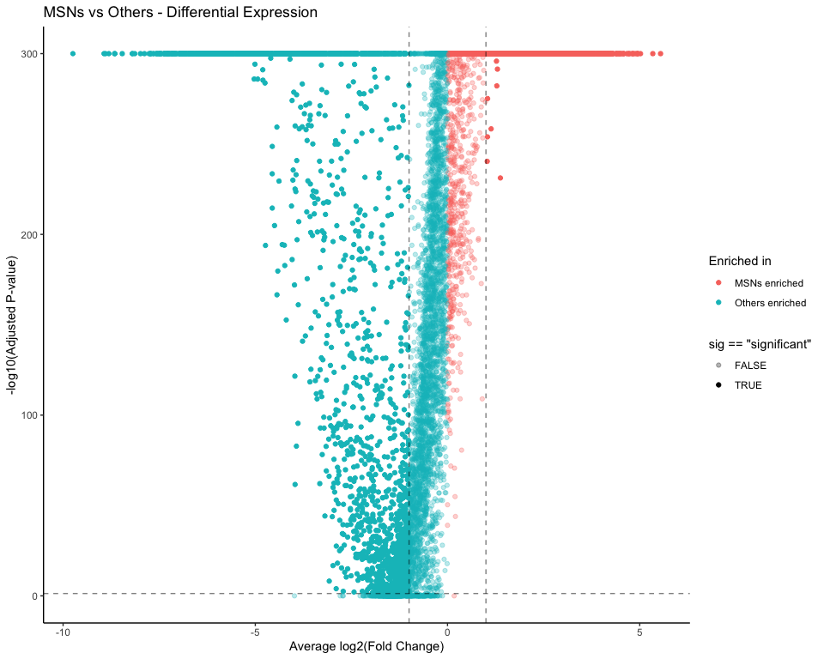

## GO and KEGG Enrichment Analysis

if (exists("markers_msn_vs_others") && nrow(markers_msn_vs_others) > 100) {  
 cat("Running GO and KEGG Enrichment Analysis\n")  
   
 # Get significant genes for enrichment  
 sig_genes_up <- markers_msn_vs_others %>%  
 filter(!is.na(p_val_adj), p_val_adj < 0.05, avg_log2FC > 1) %>%  
 pull(gene)  
   
 sig_genes_down <- markers_msn_vs_others %>%  
 filter(!is.na(p_val_adj), p_val_adj < 0.05, avg_log2FC < -1) %>%  
 pull(gene)  
   
 sig_genes_all <- markers_msn_vs_others %>%  
 filter(!is.na(p_val_adj), p_val_adj < 0.05, abs(avg_log2FC) > 1) %>%  
 pull(gene)  
   
 cat(paste("Upregulated genes:", length(sig_genes_up)), "\n")  
 cat(paste("Downregulated genes:", length(sig_genes_down)), "\n")  
 cat(paste("Total significant genes:", length(sig_genes_all)), "\n")  
   
 # Function to run GO enrichment  
 run_go_enrichment <- function(gene_list, ont_type, title_suffix) {  
 if (length(gene_list) < 10) {  
 cat(paste("Too few genes for", title_suffix, "analysis\n"))  
 return(NULL)  
 }  
   
 # Filter genes that exist in the annotation database  
 valid_genes <- gene_list[gene_list %in% keys(org.Hs.eg.db, keytype = "SYMBOL")]  
   
 if (length(valid_genes) < 10) {  
 cat(paste("Too few valid genes for", title_suffix, "analysis\n"))  
 return(NULL)  
 }  
   
 ego <- enrichGO(  
 gene = valid_genes,  
 OrgDb = org.Hs.eg.db,  
 keyType = "SYMBOL",  
 ont = ont_type,  
 pAdjustMethod = "BH",  
 pvalueCutoff = 0.05,  
 qvalueCutoff = 0.2,  
 readable = TRUE  
 )  
   
 if (is.null(ego) || nrow(as.data.frame(ego)) == 0) {  
 cat(paste("No significant GO terms found for", title_suffix), "\n")  
 return(NULL)  
 }  
   
 ego_df <- as.data.frame(ego)  
   
 # Save results  
 write.csv(ego_df, paste0("MSNvsO_tables/GO_", ont_type, "_", title_suffix, ".csv"), row.names = FALSE)  
   
 # Create plots  
 if (nrow(ego_df) > 0) {  
 p_bar <- barplot(ego, showCategory = 15, title = paste("GO", ont_type, title_suffix))  
 p_dot <- dotplot(ego, showCategory = 15, title = paste("GO", ont_type, title_suffix))  
   
 ggsave(paste0("MSNvsO_figures/GO_", ont_type, "_", title_suffix, "_Barplot.png"),   
 p_bar, width = 12, height = 8)  
 ggsave(paste0("MSNvsO_figures/GO_", ont_type, "_", title_suffix, "_Dotplot.png"),   
 p_dot, width = 12, height = 8)  
   
 print(p_bar)  
 print(p_dot)  
 }  
   
 return(ego)  
 }  
   
 # Function to run KEGG enrichment  
 run_kegg_enrichment <- function(gene_list, title_suffix) {  
 if (length(gene_list) < 10) {  
 cat(paste("Too few genes for KEGG", title_suffix, "analysis\n"))  
 return(NULL)  
 }  
   
 # Convert symbols to ENTREZ IDs  
 gene_entrez <- bitr(gene_list, fromType = "SYMBOL", toType = "ENTREZID",   
 OrgDb = org.Hs.eg.db, drop = TRUE)  
   
 if (nrow(gene_entrez) < 10) {  
 cat(paste("Too few mappable genes for KEGG", title_suffix, "analysis\n"))  
 return(NULL)  
 }  
   
 ekegg <- enrichKEGG(  
 gene = gene_entrez$ENTREZID,  
 organism = "hsa",  
 pvalueCutoff = 0.05,  
 pAdjustMethod = "BH",  
 qvalueCutoff = 0.2  
 )  
   
 if (is.null(ekegg) || nrow(as.data.frame(ekegg)) == 0) {  
 cat(paste("No significant KEGG pathways found for", title_suffix), "\n")  
 return(NULL)  
 }  
   
 # Convert back to gene symbols for readability  
 ekegg <- setReadable(ekegg, OrgDb = org.Hs.eg.db, keyType = "ENTREZID")  
 ekegg_df <- as.data.frame(ekegg)  
   
 # Save results  
 write.csv(ekegg_df, paste0("MSNvsO_tables/KEGG_", title_suffix, ".csv"), row.names = FALSE)  
   
 # Create plots  
 if (nrow(ekegg_df) > 0) {  
 p_bar <- barplot(ekegg, showCategory = 15, title = paste("KEGG Pathways", title_suffix))  
 p_dot <- dotplot(ekegg, showCategory = 15, title = paste("KEGG Pathways", title_suffix))  
   
 ggsave(paste0("MSNvsO_figures/KEGG_", title_suffix, "_Barplot.png"),   
 p_bar, width = 12, height = 8)  
 ggsave(paste0("MSNvsO_figures/KEGG_", title_suffix, "_Dotplot.png"),   
 p_dot, width = 12, height = 8)  
   
 print(p_bar)  
 print(p_dot)  
 }  
   
 return(ekegg)  
 }  
   
 # Run GO enrichment for all significant genes  
 if (length(sig_genes_all) >= 10) {  
 cat("Running GO enrichment for all significant genes\n")  
 ego_bp_all <- run_go_enrichment(sig_genes_all, "BP", "All_Significant")  
 ego_mf_all <- run_go_enrichment(sig_genes_all, "MF", "All_Significant")  
 ego_cc_all <- run_go_enrichment(sig_genes_all, "CC", "All_Significant")  
 }  
   
 # Run GO enrichment for upregulated genes  
 if (length(sig_genes_up) >= 10) {  
 cat("Running GO enrichment for upregulated genes\n")  
 ego_bp_up <- run_go_enrichment(sig_genes_up, "BP", "Upregulated")  
 ego_mf_up <- run_go_enrichment(sig_genes_up, "MF", "Upregulated")  
 ego_cc_up <- run_go_enrichment(sig_genes_up, "CC", "Upregulated")  
 }  
   
 # Run GO enrichment for downregulated genes  
 if (length(sig_genes_down) >= 10) {  
 cat("Running GO enrichment for downregulated genes\n")  
 ego_bp_down <- run_go_enrichment(sig_genes_down, "BP", "Downregulated")  
 ego_mf_down <- run_go_enrichment(sig_genes_down, "MF", "Downregulated")  
 ego_cc_down <- run_go_enrichment(sig_genes_down, "CC", "Downregulated")  
 }  
   
 # Run KEGG enrichment  
 if (length(sig_genes_all) >= 10) {  
 cat("Running KEGG enrichment for all significant genes\n")  
 ekegg_all <- run_kegg_enrichment(sig_genes_all, "All_Significant")  
 }  
   
 if (length(sig_genes_up) >= 10) {  
 cat("Running KEGG enrichment for upregulated genes\n")  
 ekegg_up <- run_kegg_enrichment(sig_genes_up, "Upregulated")  
 }  
   
 if (length(sig_genes_down) >= 10) {  
 cat("Running KEGG enrichment for downregulated genes\n")  
 ekegg_down <- run_kegg_enrichment(sig_genes_down, "Downregulated")  
 }  
   
 # Create comparison plots if multiple enrichment results exist  
 if (exists("ego_bp_up") && exists("ego_bp_down") &&   
 !is.null(ego_bp_up) && !is.null(ego_bp_down)) {  
   
 # Compare upregulated vs downregulated GO BP terms  
 comparison_plot <- compareCluster(  
 list(Upregulated = sig_genes_up, Downregulated = sig_genes_down),  
 fun = "enrichGO",  
 OrgDb = org.Hs.eg.db,  
 ont = "BP",  
 pAdjustMethod = "BH",  
 pvalueCutoff = 0.05,  
 readable = TRUE  
 )  
   
 if (!is.null(comparison_plot) && nrow(as.data.frame(comparison_plot)) > 0) {  
 p_compare <- dotplot(comparison_plot, showCategory = 10,   
 title = "GO Biological Process: Up vs Down Regulated")  
 ggsave("MSNvsO_figures/GO_BP_Comparison_Up_vs_Down.png",   
 p_compare, width = 14, height = 10)  
 print(p_compare)  
   
 write.csv(as.data.frame(comparison_plot),   
 "MSNvsO_tables/GO_BP_Comparison_Up_vs_Down.csv", row.names = FALSE)  
 }  
 }  
   
 # Create enrichment summary  
 enrichment_summary <- data.frame(  
 Analysis = character(),  
 Category = character(),  
 Significant_Terms = numeric(),  
 Top_Term = character(),  
 Top_Term_Pvalue = numeric()  
 )  
   
 # Function to add to summary  
 add_to_summary <- function(result, analysis_name, category_name) {  
 if (!is.null(result) && nrow(as.data.frame(result)) > 0) {  
 result_df <- as.data.frame(result)  
 return(data.frame(  
 Analysis = analysis_name,  
 Category = category_name,  
 Significant_Terms = nrow(result_df),  
 Top_Term = result_df$Description[1],  
 Top_Term_Pvalue = result_df$p.adjust[1]  
 ))  
 }  
 return(NULL)  
 }  
   
 # Add all results to summary  
 summary_additions <- list()  
 if (exists("ego_bp_all")) summary_additions <- append(summary_additions, list(add_to_summary(ego_bp_all, "All_Significant", "GO_BP")))  
 if (exists("ego_mf_all")) summary_additions <- append(summary_additions, list(add_to_summary(ego_mf_all, "All_Significant", "GO_MF")))  
 if (exists("ego_cc_all")) summary_additions <- append(summary_additions, list(add_to_summary(ego_cc_all, "All_Significant", "GO_CC")))  
 if (exists("ekegg_all")) summary_additions <- append(summary_additions, list(add_to_summary(ekegg_all, "All_Significant", "KEGG")))  
   
 if (exists("ego_bp_up")) summary_additions <- append(summary_additions, list(add_to_summary(ego_bp_up, "Upregulated", "GO_BP")))  
 if (exists("ego_bp_down")) summary_additions <- append(summary_additions, list(add_to_summary(ego_bp_down, "Downregulated", "GO_BP")))  
 if (exists("ekegg_up")) summary_additions <- append(summary_additions, list(add_to_summary(ekegg_up, "Upregulated", "KEGG")))  
 if (exists("ekegg_down")) summary_additions <- append(summary_additions, list(add_to_summary(ekegg_down, "Downregulated", "KEGG")))  
   
 # Combine all summary additions  
 valid_summaries <- summary_additions[!sapply(summary_additions, is.null)]  
 if (length(valid_summaries) > 0) {  
 enrichment_summary <- do.call(rbind, valid_summaries)  
 write.csv(enrichment_summary, "MSNvsO_tables/Enrichment_Analysis_Summary.csv", row.names = FALSE)  
 print("Enrichment Analysis Summary:")  
 print(enrichment_summary)  
   
 # Plot summary  
 if (nrow(enrichment_summary) > 0) {  
 p_summary <- ggplot(enrichment_summary, aes(x = paste(Analysis, Category, sep = "_"),   
 y = Significant_Terms)) +  
 geom_col(fill = "steelblue", alpha = 0.7) +  
 geom_text(aes(label = Significant_Terms), vjust = -0.5) +  
 labs(title = "Number of Significant Terms by Analysis",  
 x = "Analysis_Category", y = "Number of Significant Terms") +  
 theme_minimal() +  
 theme(axis.text.x = element_text(angle = 45, hjust = 1))  
   
 ggsave("MSNvsO_figures/Enrichment_Summary.png", p_summary, width = 12, height = 6)  
 print(p_summary)  
 }  
 }  
   
} else {  
 cat("Insufficient genes for GO and KEGG enrichment analysis\n")  
}

## Running GO and KEGG Enrichment Analysis  
## Upregulated genes: 1742   
## Downregulated genes: 2101   
## Total significant genes: 3843   
## Running GO enrichment for all significant genes

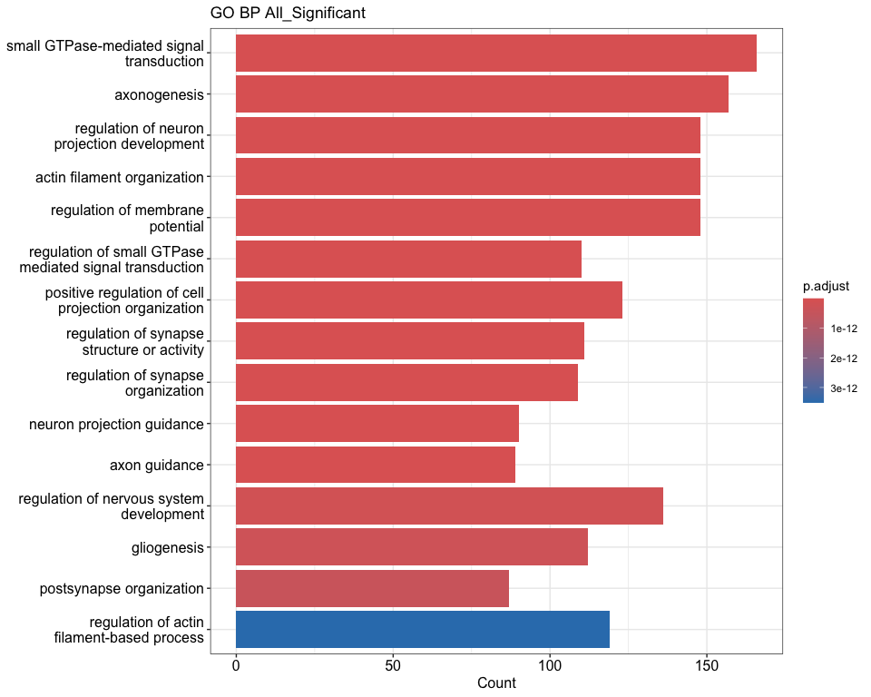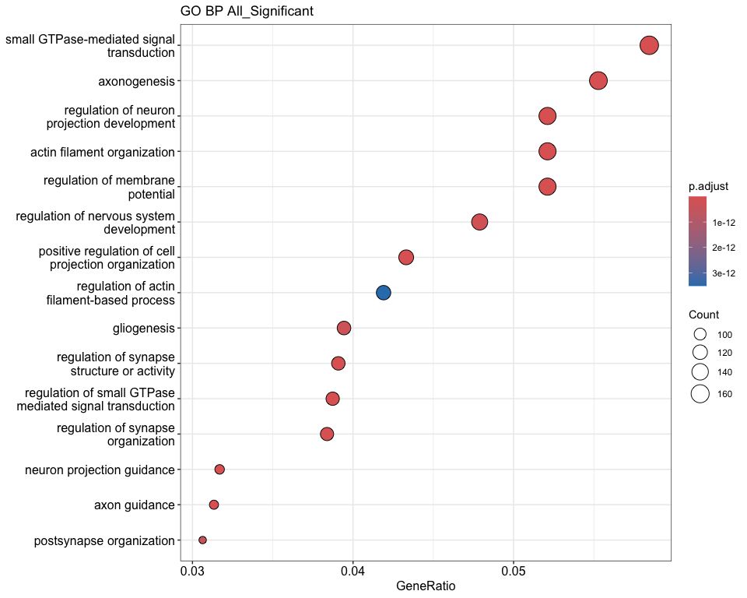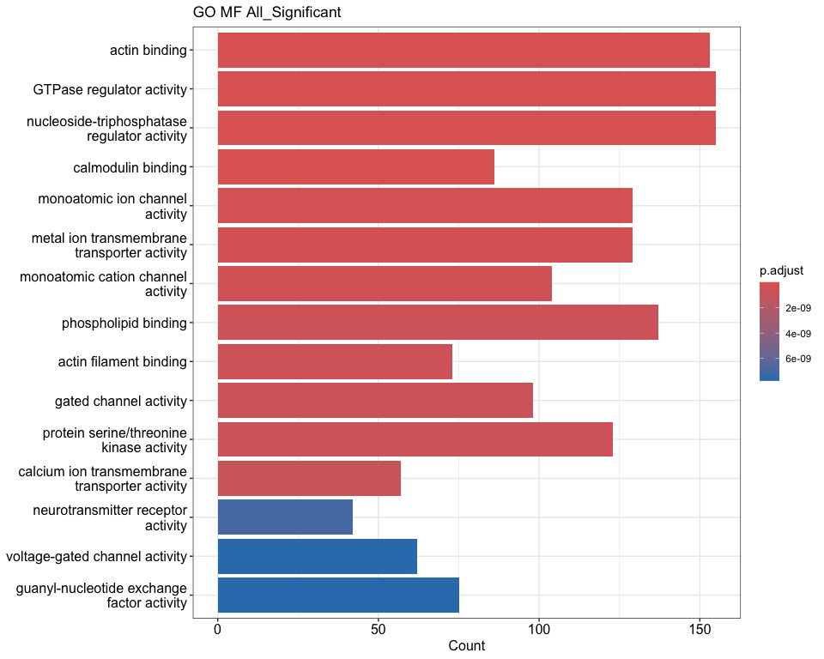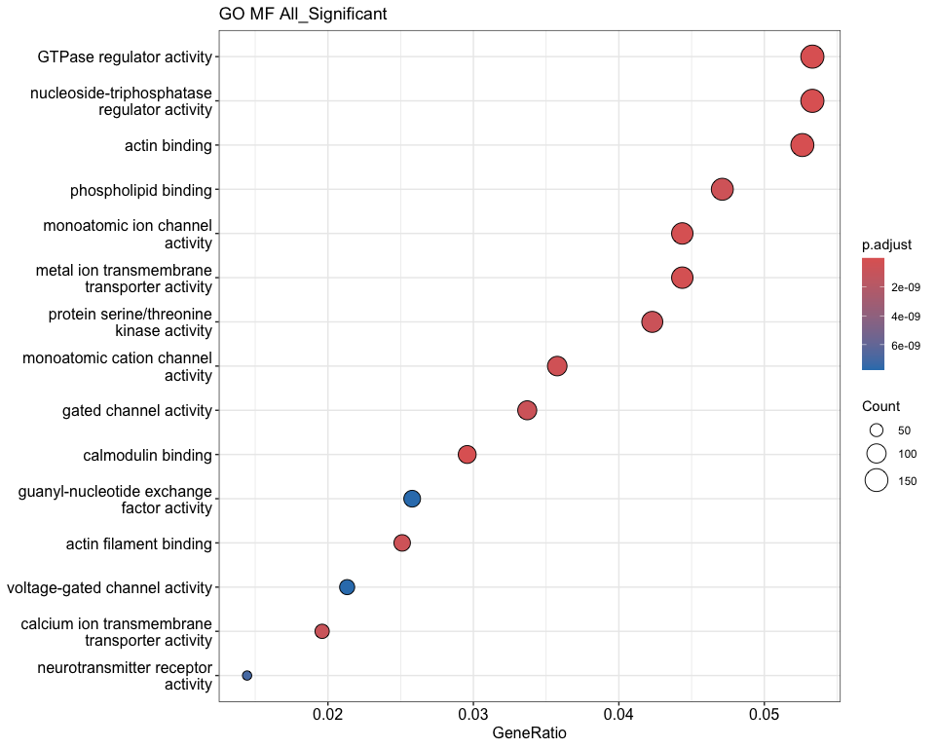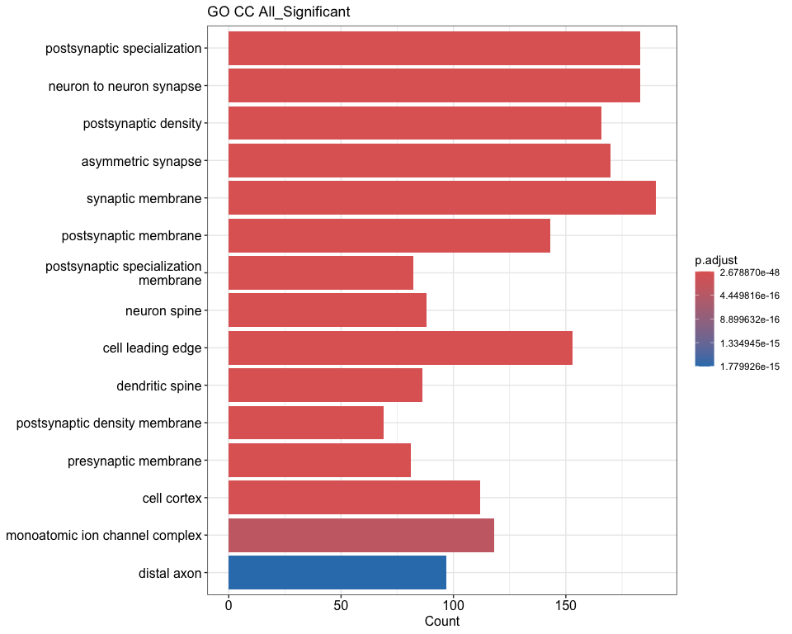

## Running GO enrichment for upregulated genes

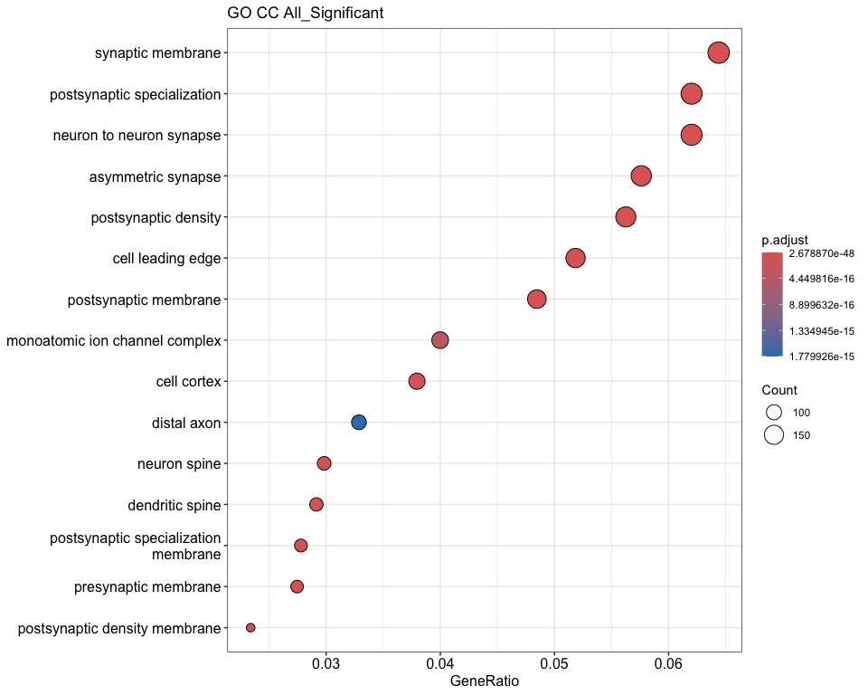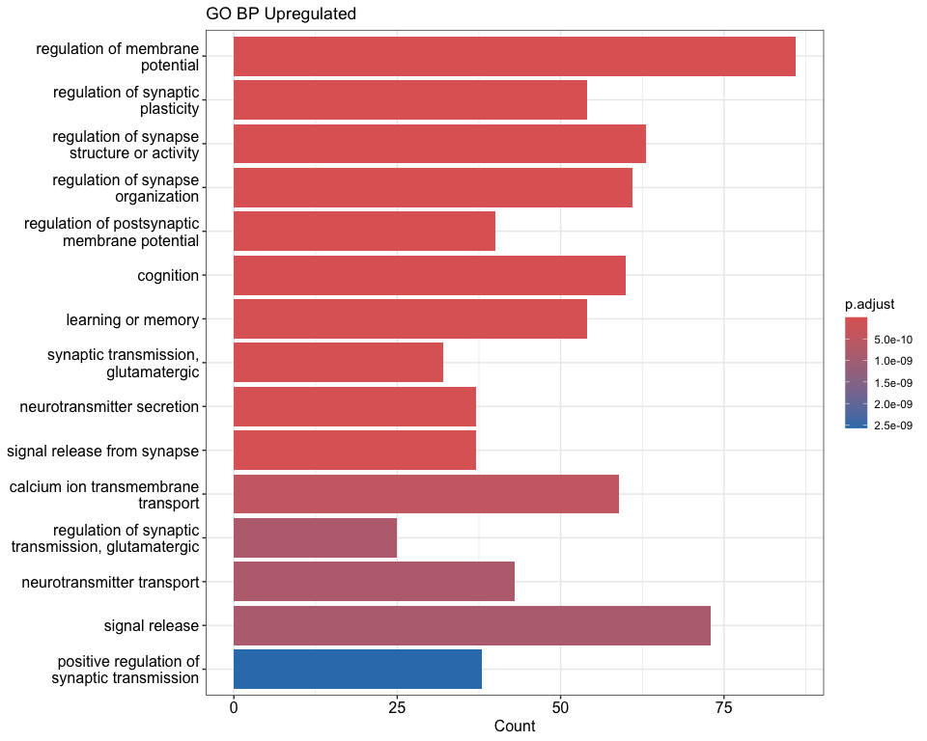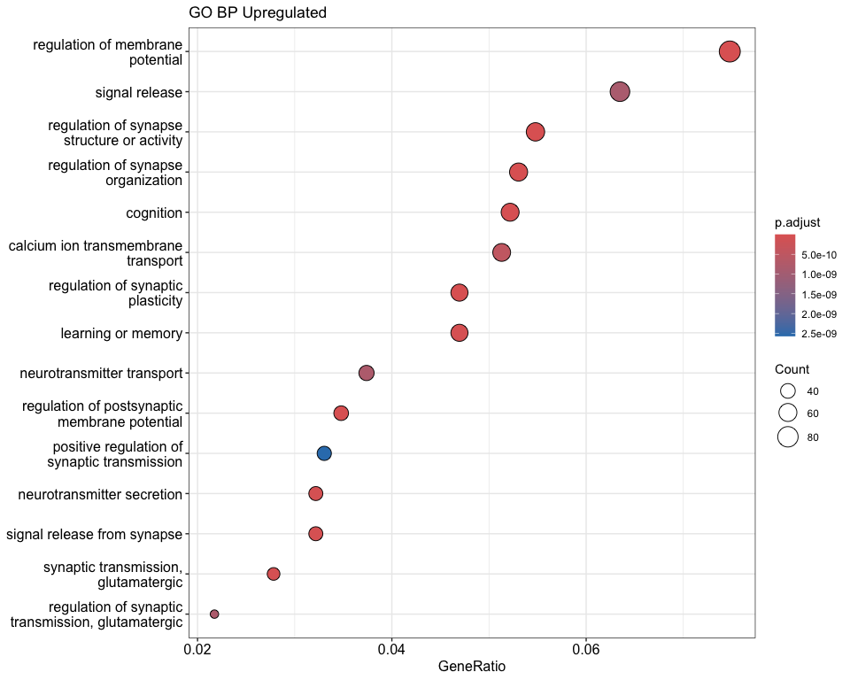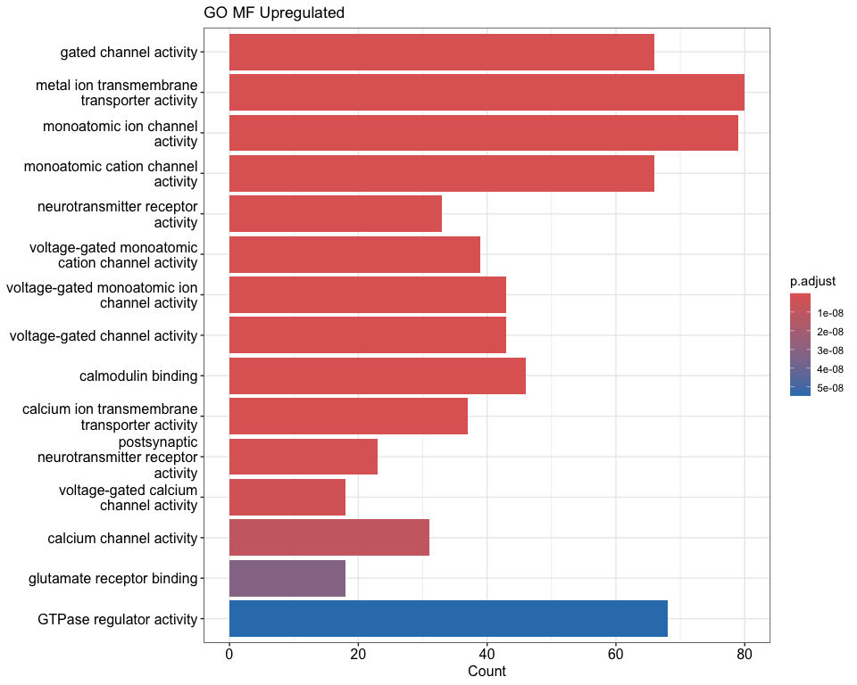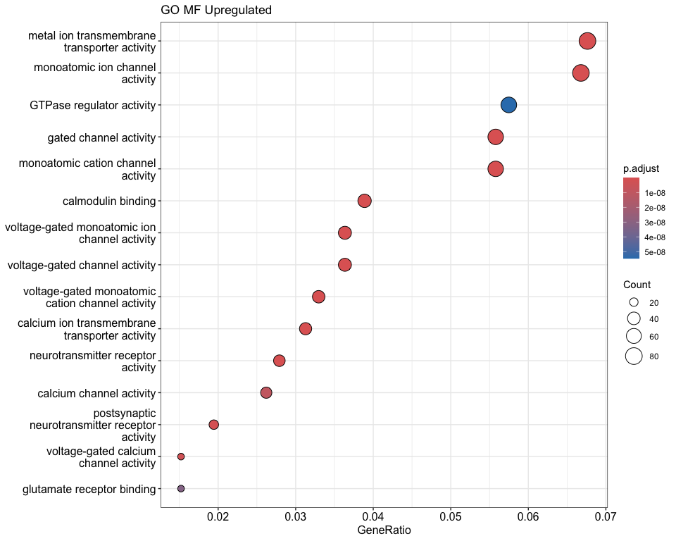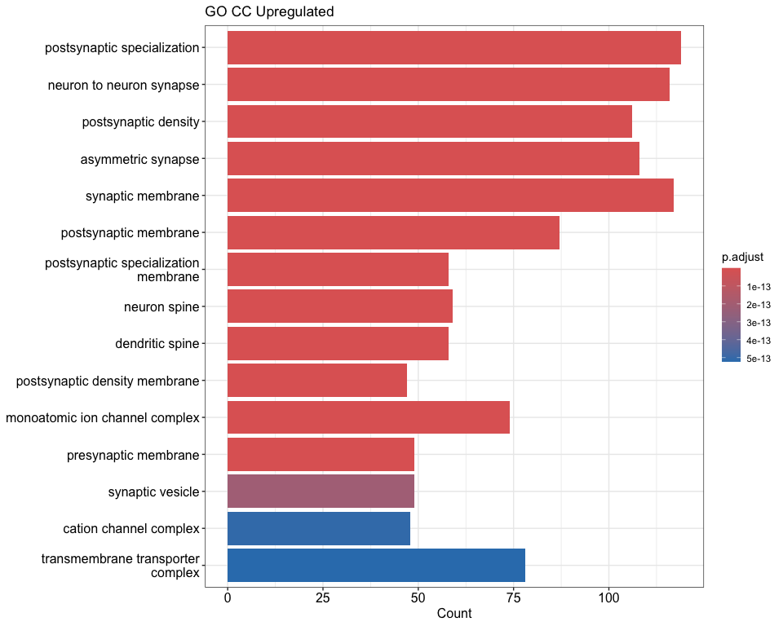

## Running GO enrichment for downregulated genes

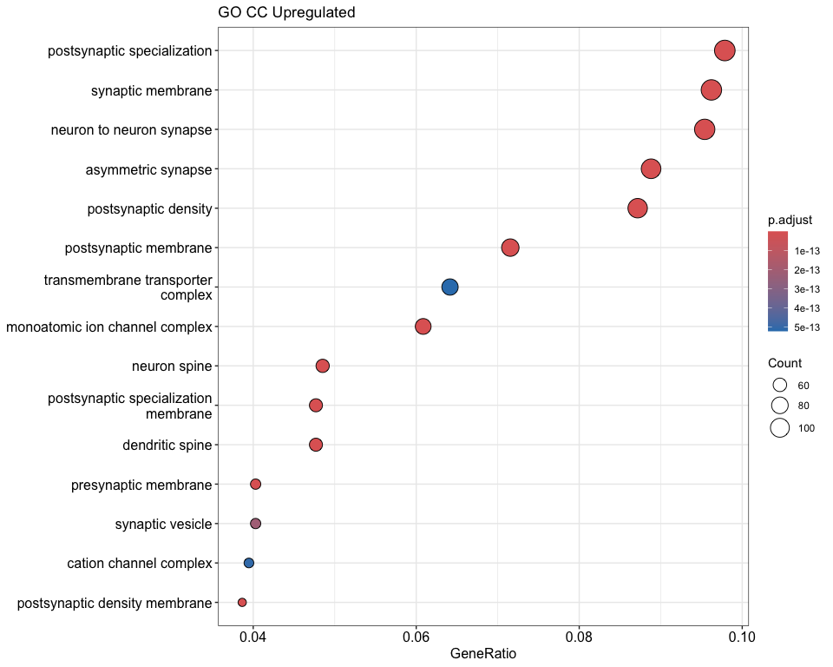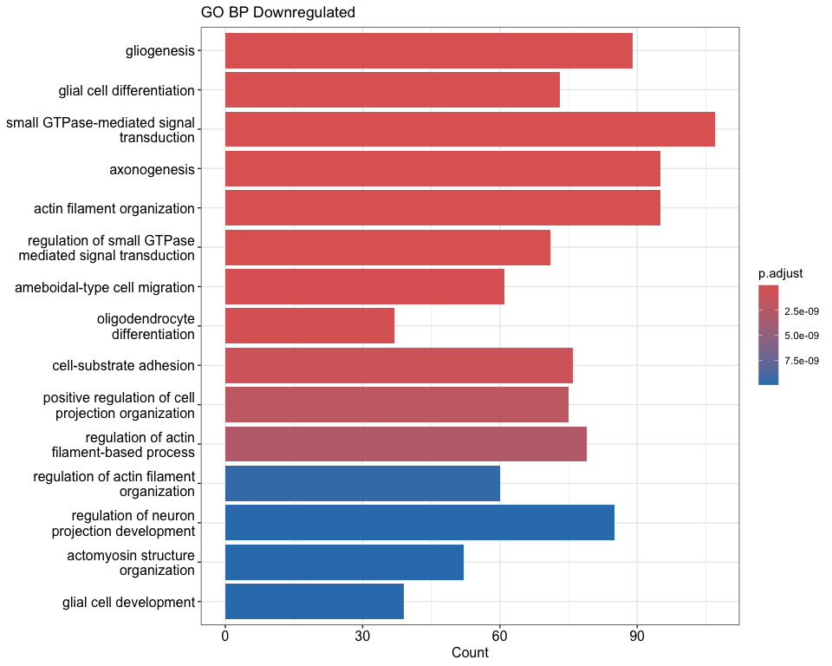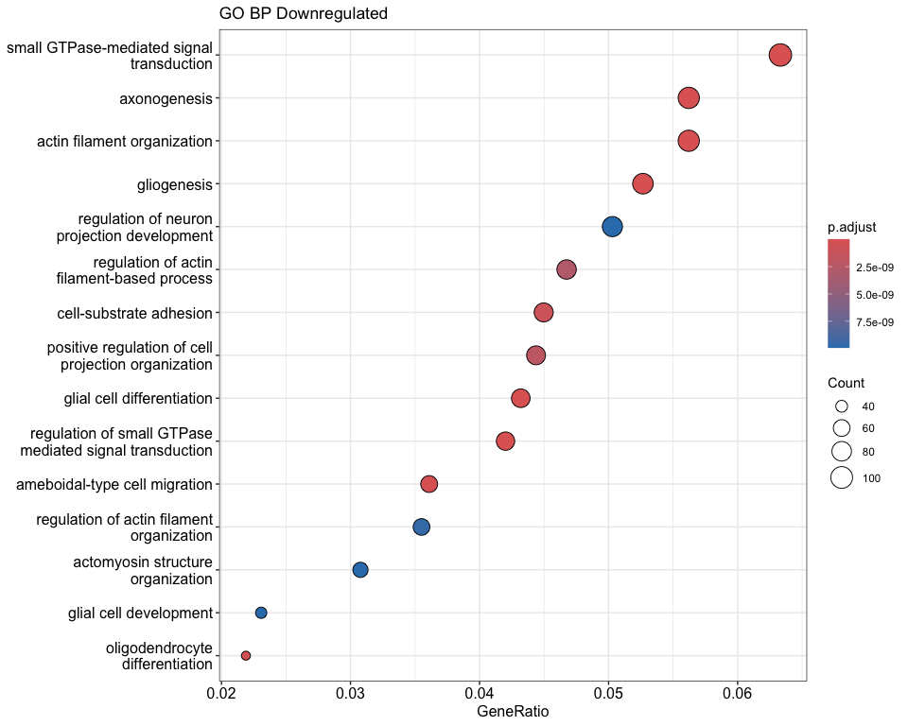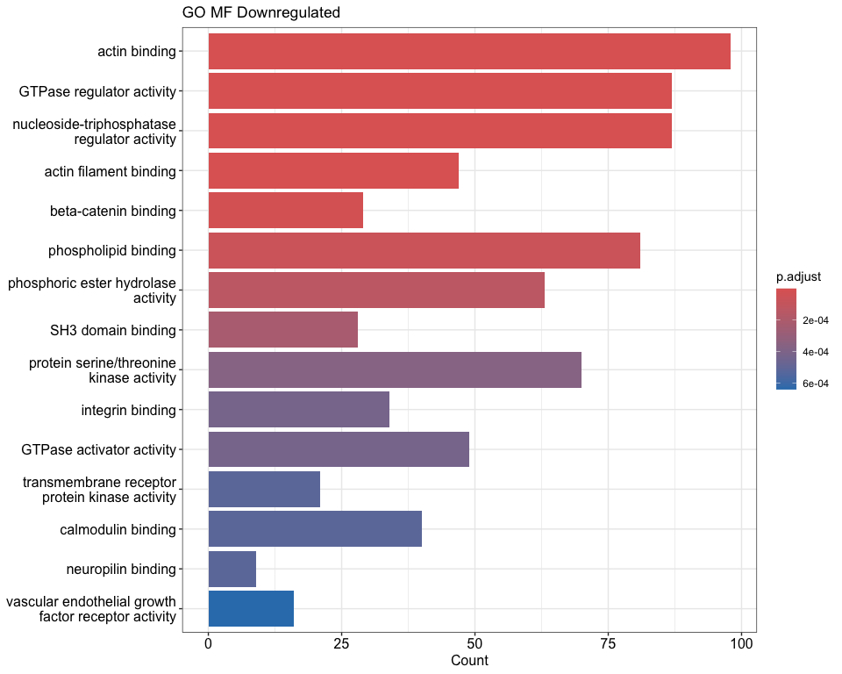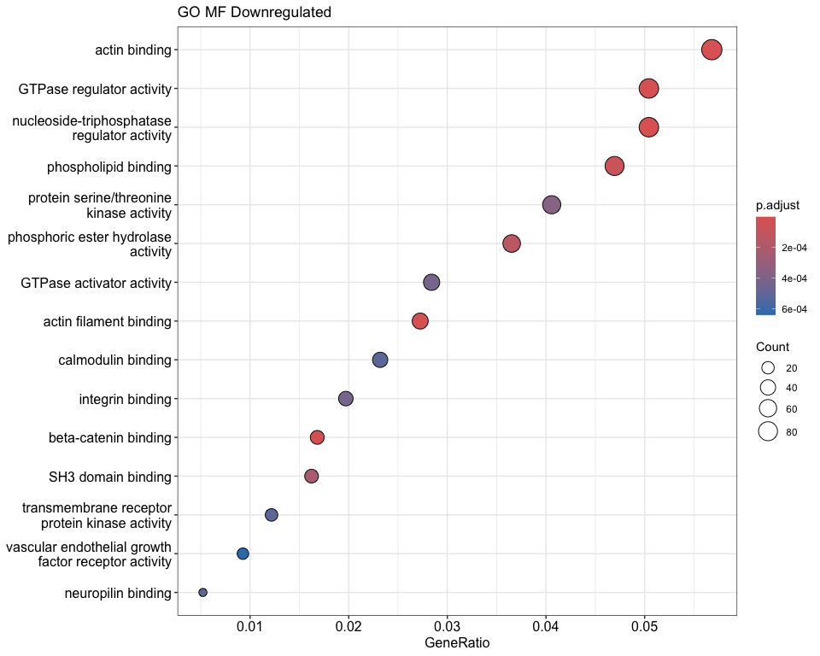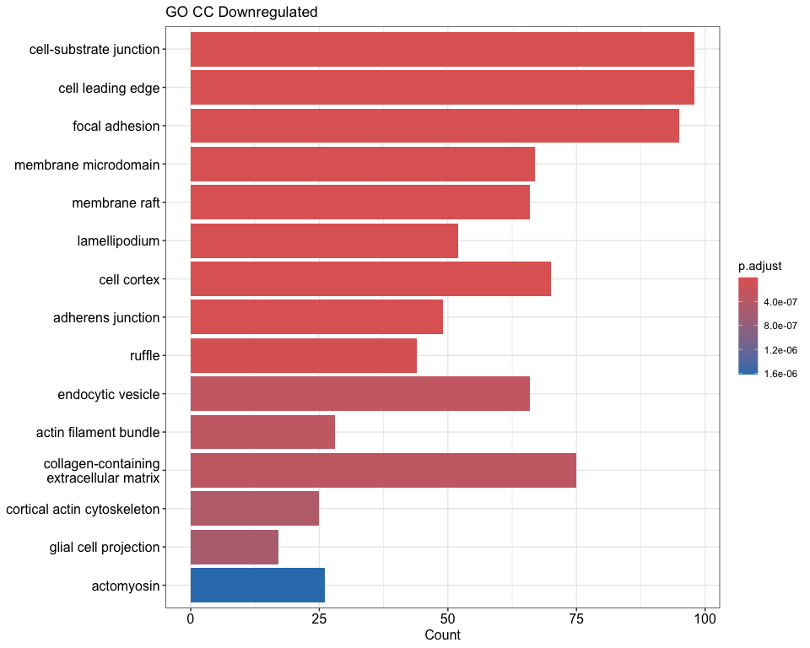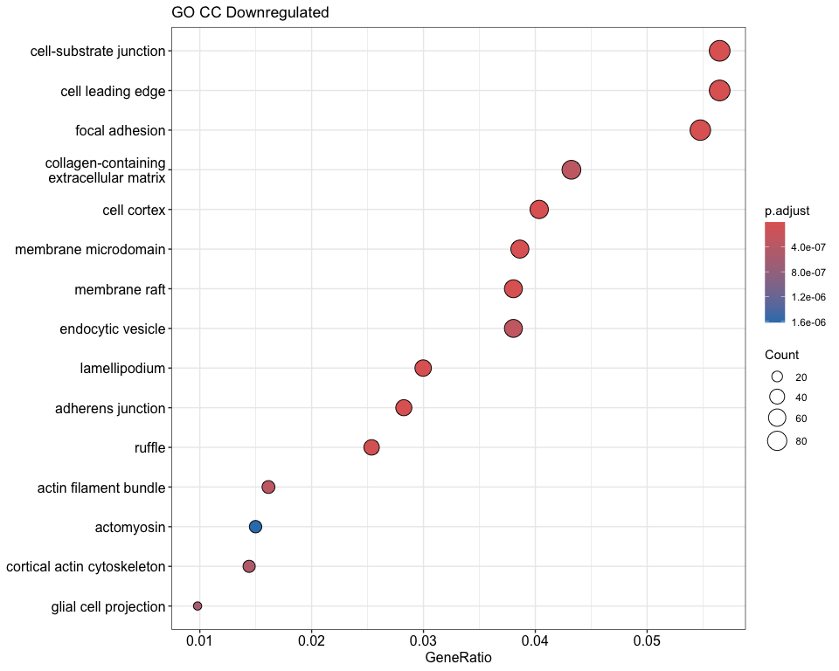

## Running KEGG enrichment for all significant genes

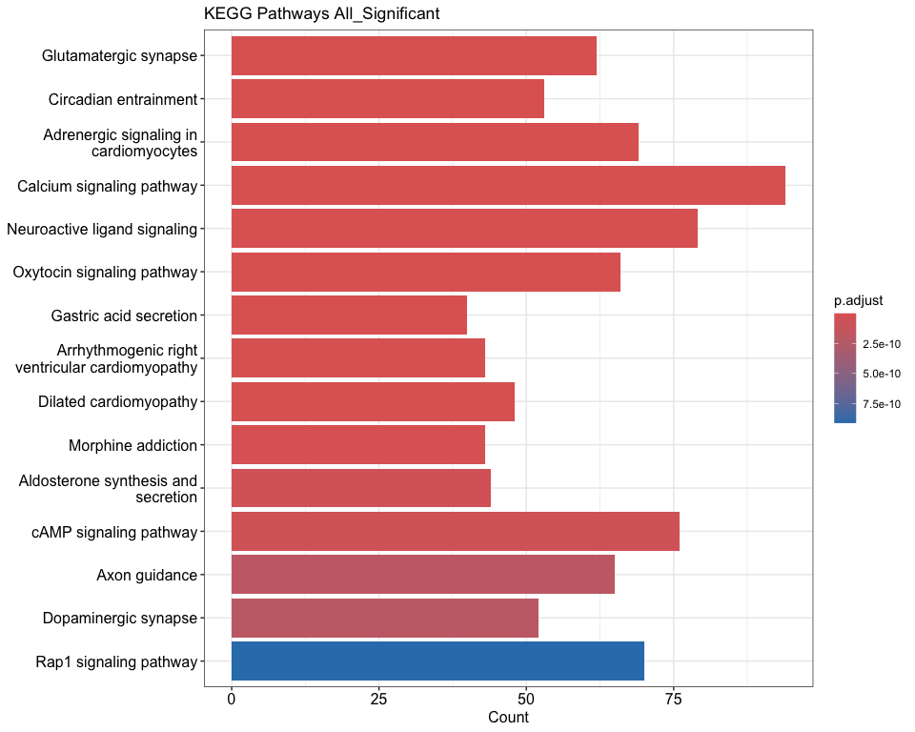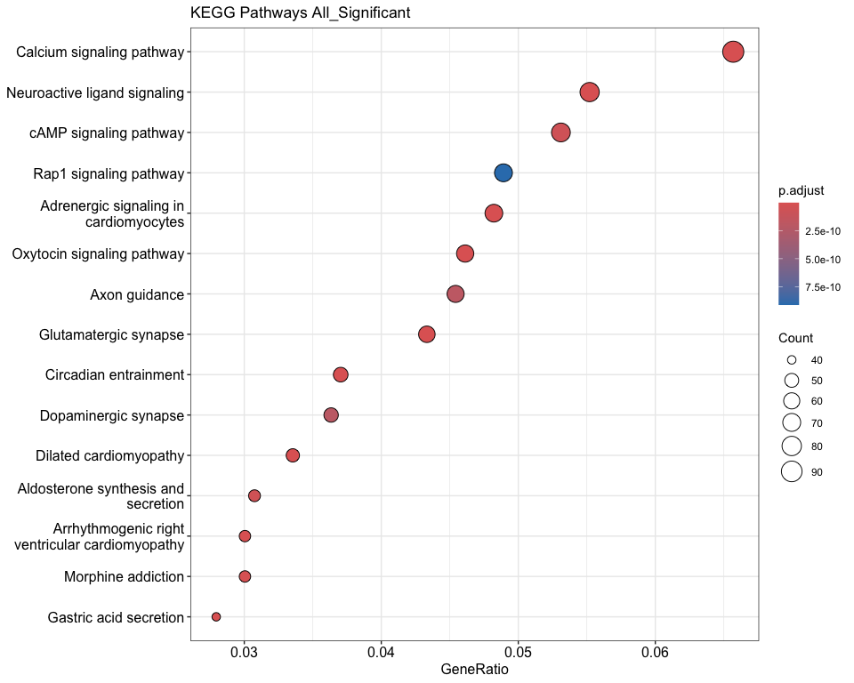

## Running KEGG enrichment for upregulated genes

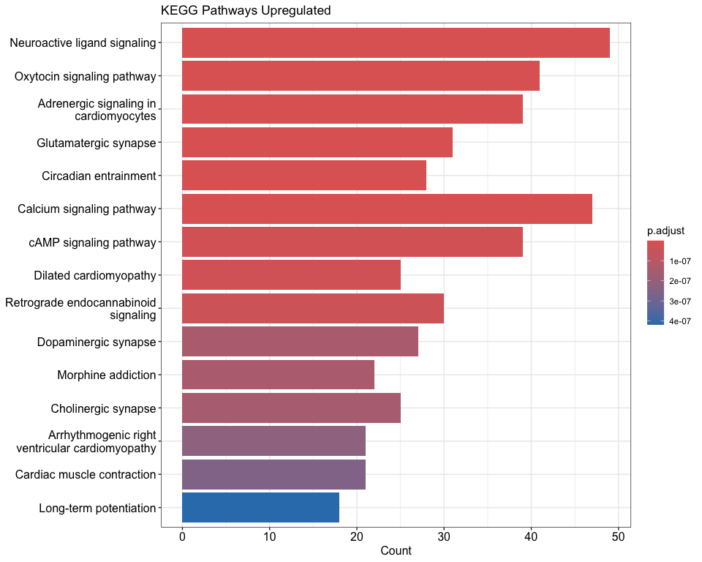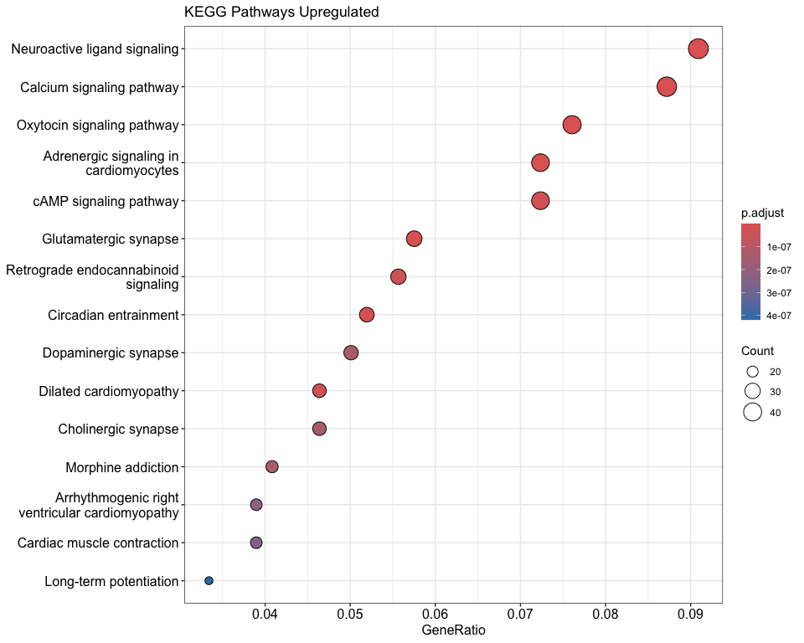

## Running KEGG enrichment for downregulated genes

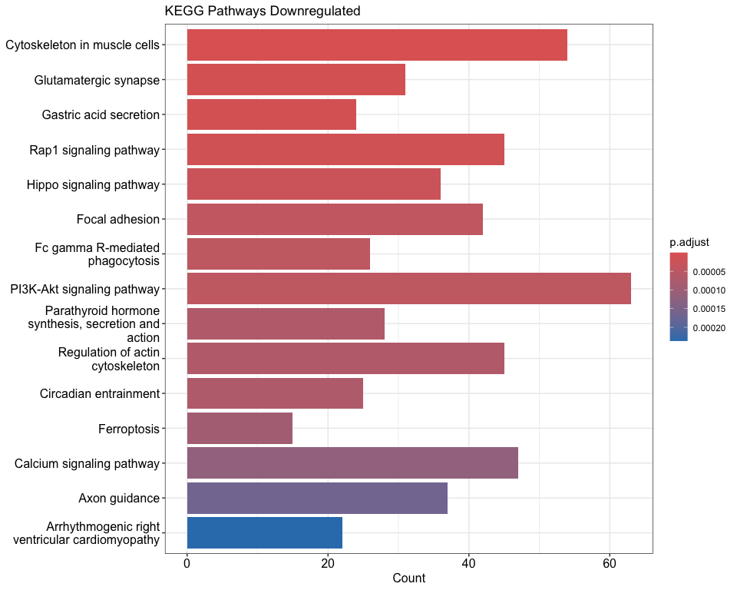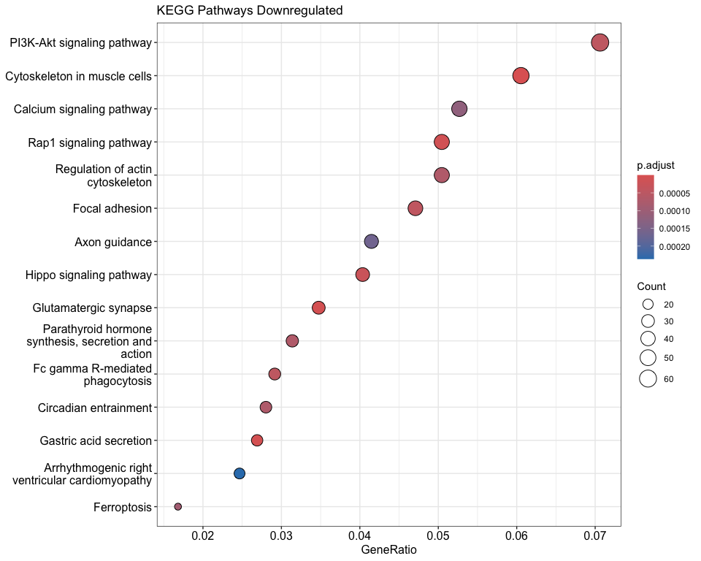

## [1] "Enrichment Analysis Summary:"  
## Analysis Category Significant_Terms  
## 1 All_Significant GO_BP 1087  
## 2 All_Significant GO_MF 211  
## 3 All_Significant GO_CC 176  
## 4 All_Significant KEGG 99  
## 5 Upregulated GO_BP 386  
## 6 Downregulated GO_BP 863  
## 7 Upregulated KEGG 51  
## 8 Downregulated KEGG 85  
## Top_Term Top_Term_Pvalue  
## 1 small GTPase-mediated signal transduction 2.246708e-22  
## 2 actin binding 2.852675e-20  
## 3 postsynaptic specialization 2.678870e-48  
## 4 Glutamatergic synapse 1.846911e-19  
## 5 regulation of membrane potential 4.469117e-17  
## 6 gliogenesis 2.145078e-16  
## 7 Neuroactive ligand signaling 1.801191e-16  
## 8 Cytoskeleton in muscle cells 8.947692e-08

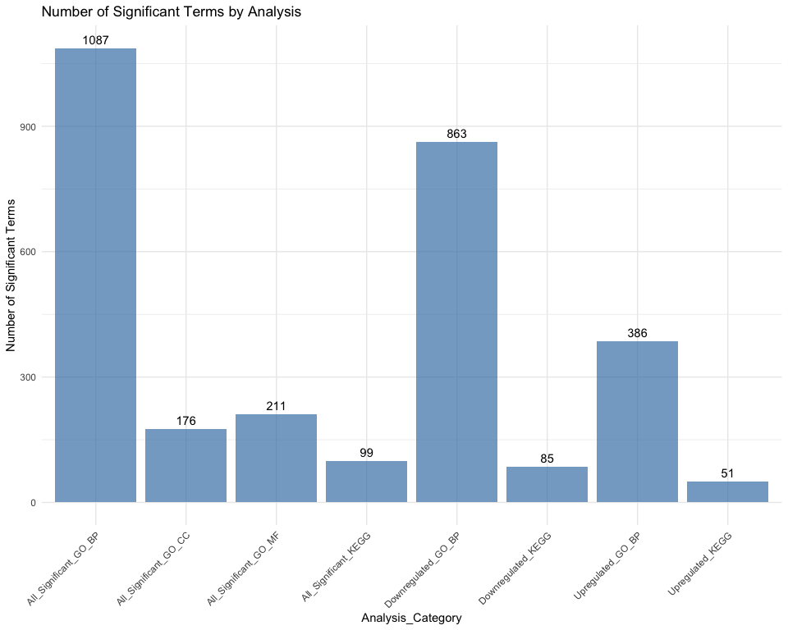

## Epigenetic Regulator Expression Analysis

# Define epigenetic genes of interest  
epi_genes <- c(  
 # DNA methylation  
 "DNMT1","DNMT3A","DNMT3B","TET1","TET2","TET3","UHRF1",  
 # Histone writers  
 "EZH2","EZH1","SUZ12","EED","KMT2A","KMT2D","SETD1A","SETD1B",  
 "KMT5A","KMT5B","KMT5C","EHMT1","EHMT2","SUV39H1","SUV39H2",  
 # Histone erasers  
 "KDM1A","KDM1B","KDM4A","KDM4B","KDM4C","KDM5A","KDM5B","KDM6A","KDM6B",  
 "HDAC1","HDAC2","HDAC3","SIRT1","SIRT2","SIRT6",  
 # Chromatin remodeling  
 "SMARCA4","SMARCA2","SMARCB1","CHD1","CHD2","CHD7","CHD8",  
 # DNA binding/regulation  
 "MECP2","MBD1","MBD2","MBD3","CTCF","SATB1","SATB2"  
)  
  
# Filter genes present in dataset  
present_epi_genes <- intersect(epi_genes, rownames(so_filtered))  
missing_epi_genes <- setdiff(epi_genes, present_epi_genes)  
  
cat(paste("Present epigenetic genes:", length(present_epi_genes)), "\n")

## Present epigenetic genes: 48

cat(paste("Missing epigenetic genes:", length(missing_epi_genes)), "\n")

## Missing epigenetic genes: 3

if (length(present_epi_genes) > 0) {  
 # Calculate scores for a small subset of writer/eraser genes  
 histone_writers <- intersect(c("EZH2", "KMT2A", "KMT2D", "SETD1A", "SETD1B"), rownames(so_filtered))  
 histone_erasers <- intersect(c("KDM1A", "KDM4A", "KDM6A", "KDM6B", "HDAC1", "HDAC2"), rownames(so_filtered))  
  
 if (length(histone_writers) > 0) {  
 so_filtered$writer_score <- colMeans(GetAssayData(so_filtered, layer = "data")[histone_writers, , drop = FALSE])  
 }  
 if (length(histone_erasers) > 0) {  
 so_filtered$eraser_score <- colMeans(GetAssayData(so_filtered, layer = "data")[histone_erasers, , drop = FALSE])  
 }  
 if (length(histone_writers) > 0 && length(histone_erasers) > 0) {  
 so_filtered$writer_eraser_ratio <- so_filtered$writer_score / (so_filtered$eraser_score + 0.1)  
 }  
  
 # Basic violin plots  
 if ("writer_score" %in% colnames(so_filtered@meta.data)) {  
 p_writer <- VlnPlot(so_filtered, features = "writer_score", group.by = "MSN_vs_Others") +  
 ggtitle("Histone Writer Score")  
 ggsave("MSNvsO_figures/Histone_Writer_Score.png", p_writer, width = 8, height = 6)  
 }  
  
 if ("writer_eraser_ratio" %in% colnames(so_filtered@meta.data)) {  
 p_ratio <- VlnPlot(so_filtered, features = "writer_eraser_ratio", group.by = "MSN_vs_Others") +  
 ggtitle("Writer/Eraser Ratio")  
 ggsave("MSNvsO_figures/Writer_Eraser_Ratio.png", p_ratio, width = 8, height = 6)  
 }  
  
 # Limit to top 6 epigenetic genes for compact plotting  
 top_epi_genes <- present_epi_genes[1:min(6, length(present_epi_genes))]  
  
 p18 <- VlnPlot(so_filtered, features = top_epi_genes,  
 group.by = "MSN_vs_Others",  
 pt.size = 0, ncol = 3) +  
 theme_minimal() + ggtitle("Top Epigenetic Regulator Expression")  
 ggsave("MSNvsO_figures/Epigenetic_Regulators_ViolinPlot.png", p18, width = 12, height = 8)  
  
 # DotPlot for top genes only  
 p_dot <- DotPlot(so_filtered, features = top_epi_genes, group.by = "MSN_vs_Others") +  
 RotatedAxis() +  
 scale_color_gradientn(colors = c("skyblue", "white", "coral")) +  
 ggtitle("DotPlot: Top Epigenetic Regulators")  
 ggsave("MSNvsO_figures/Epigenetic_Regulators_DotPlot.png", p_dot, width = 10, height = 6)  
  
 # DE results if available  
 if (exists("sc_sig")) {  
 epi_de_results <- sc_sig %>%  
 filter(gene %in% present_epi_genes) %>%  
 arrange(p_val_adj)  
 if (nrow(epi_de_results) > 0) {  
 write.csv(epi_de_results, "MSNvsO_tables/Epigenetic_Regulators_DE_singlecell.csv", row.names = FALSE)  
 }  
 }  
  
# Gene category annotations  
epi_categories <- data.frame(  
 gene = present_epi_genes,  
 category = case_when(  
 present_epi_genes %in% c("DNMT1","DNMT3A","DNMT3B","TET1","TET2","TET3","UHRF1") ~ "DNA Methylation",  
 present_epi_genes %in% c("EZH2","EZH1","SUZ12","EED","KMT2A","KMT2D","SETD1A","SETD1B",  
 "KMT5A","KMT5B","KMT5C","EHMT1","EHMT2","SUV39H1","SUV39H2") ~ "Histone Writers",  
 present_epi_genes %in% c("KDM1A","KDM1B","KDM4A","KDM4B","KDM4C","KDM5A","KDM5B",  
 "KDM6A","KDM6B","HDAC1","HDAC2","HDAC3","SIRT1","SIRT2","SIRT6") ~ "Histone Erasers",  
 present_epi_genes %in% c("SMARCA4","SMARCA2","SMARCB1","CHD1","CHD2","CHD7","CHD8") ~ "Chromatin Remodeling",  
 TRUE ~ "DNA Binding/Regulation"  
 )  
)  
  
  
 write.csv(epi_categories, "MSNvsO_tables/Epigenetic_Gene_Categories.csv", row.names = FALSE)  
}

## Epigenetic Network Analysis

## Pseudobulk Differential Expression Analysis with MDS Plot

if (!"MSN_vs_Others" %in% colnames(so_filtered@meta.data)) stop("MSN vs Others classification is missing.")  
  
# Simulated sample IDs if absent (documented)  
if (!"sample" %in% colnames(so_filtered@meta.data)) {  
 set.seed(123)  
 so_filtered$sample <- NA  
 for (class in unique(so_filtered$MSN_vs_Others)) {  
 class_cells <- which(so_filtered$MSN_vs_Others == class)  
 so_filtered$sample[class_cells] <- paste0("Sample_", class, "_", sample(1:3, length(class_cells), replace = TRUE))  
 }  
}  
  
counts <- GetAssayData(so_filtered, slot = "counts")  
meta_df <- so_filtered@meta.data[, c("sample", "MSN_vs_Others")]  
  
pb_counts_list <- lapply(unique(meta_df$sample), function(s) {  
 cells <- rownames(meta_df[meta_df$sample == s, ])  
 group <- unique(meta_df[meta_df$sample == s, "MSN_vs_Others"])  
 if (length(group) == 1 && length(cells) > 0) Matrix::rowSums(counts[, cells, drop = FALSE]) else NULL  
})  
  
pb_counts <- do.call(cbind, pb_counts_list)  
colnames(pb_counts) <- unique(meta_df$sample)  
  
pb_meta <- data.frame(  
 sample = colnames(pb_counts),  
 group = sapply(colnames(pb_counts), function(s) unique(meta_df[meta_df$sample == s, "MSN_vs_Others"]))  
)  
  
keep_groups <- c("MSNs", "Others")  
keep_samples <- pb_meta$group %in% keep_groups  
pb_counts <- pb_counts[, keep_samples]  
pb_meta <- pb_meta[keep_samples, , drop = FALSE]  
pb_meta$group <- factor(pb_meta$group, levels = keep_groups)  
  
dge <- DGEList(counts = pb_counts, group = pb_meta$group)  
dge <- dge[filterByExpr(dge), , keep.lib.sizes = FALSE]  
dge <- calcNormFactors(dge)  
  
design <- model.matrix(~0 + pb_meta$group)  
colnames(design) <- make.names(levels(pb_meta$group))  
  
dge <- estimateDisp(dge, design)  
  
# MDS Plot for sample relationships  
cat("Creating MDS plot for sample relationships\n")

## Creating MDS plot for sample relationships

mds_data <- plotMDS(dge, plot = FALSE)  
mds_df <- data.frame(  
 Sample = colnames(dge),  
 Dim1 = mds_data$x,  
 Dim2 = mds_data$y,  
 Group = pb_meta$group  
)  
  
p_mds <- ggplot(mds_df, aes(x = Dim1, y = Dim2, color = Group)) +  
 geom_point(size = 4) +  
 geom_text_repel(aes(label = Sample), size = 3) +  
 labs(title = "MDS Plot: Sample Relationships",  
 x = paste("Leading logFC dim 1 (", round(mds_data$var.explained[1], 1), "%)", sep = ""),  
 y = paste("Leading logFC dim 2 (", round(mds_data$var.explained[2], 1), "%)", sep = "")) +  
 theme_minimal()  
  
print(p_mds)

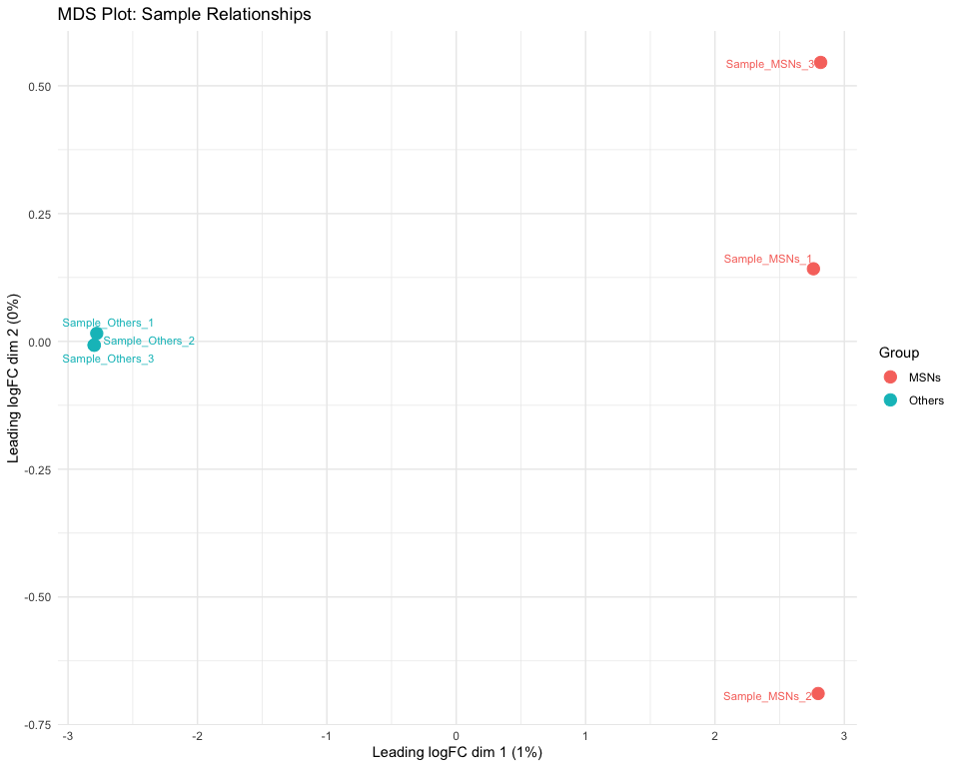

ggsave("MSNvsO_figures/MDS_Sample_Relationships.png", p_mds, width = 10, height = 8)  
  
fit <- glmFit(dge, design)  
contrast <- makeContrasts(MSNs_vs_Others = MSNs - Others, levels = design)  
lrt <- glmLRT(fit, contrast = contrast)  
  
pb_de_results <- topTags(lrt, n = Inf)$table %>%  
 rownames_to_column("gene") %>%  
 arrange(FDR)  
write.csv(pb_de_results, "MSNvsO_tables/Pseudobulk_DE_MSNs_vs_Others_all.csv", row.names = FALSE)  
  
# Apply significance criteria: abs(logFC) > 1 & FDR < 0.05  
pb_sig <- pb_de_results %>% filter(FDR < 0.05, abs(logFC) > 1)  
write.csv(pb_sig, "MSNvsO_tables/Pseudobulk_DE_MSNs_vs_Others_significant.csv", row.names = FALSE)  
  
# Enhanced volcano (pseudobulk) + highlights  
pb_de_results$log10FDR <- -log10(pb_de_results$FDR + 1e-300)  
pb_de_results$dir <- ifelse(pb_de_results$logFC > 0, "MSNs enriched", "Others enriched")  
pb_de_results$sig <- ifelse(pb_de_results$FDR < 0.05 & abs(pb_de_results$logFC) > 1, "significant", "ns")  
  
p_pb_volcano <- ggplot(pb_de_results, aes(x = logFC, y = log10FDR)) +  
 geom_point(aes(alpha = sig == "significant", color = dir), size = 1.5) +  
 scale_alpha_manual(values = c("TRUE" = 1, "FALSE" = 0.3)) +  
 scale_color_manual(values = c("MSNs enriched" = "#FF6B6B", "Others enriched" = "#4ECDC4")) +  
 labs(title = "Pseudobulk DE: MSNs vs Others",  
 x = "log2 Fold Change", y = "-log10 FDR", color = "Enriched in") +  
 theme_classic() +  
 geom_hline(yintercept = -log10(0.05), linetype = "dashed", alpha = 0.5) +  
 geom_vline(xintercept = c(-1, 1), linetype = "dashed", alpha = 0.5)  
ggsave("MSNvsO_figures/Pseudobulk_Volcano_Plot.png", p_pb_volcano, width = 10, height = 8)  
print(p_pb_volcano)

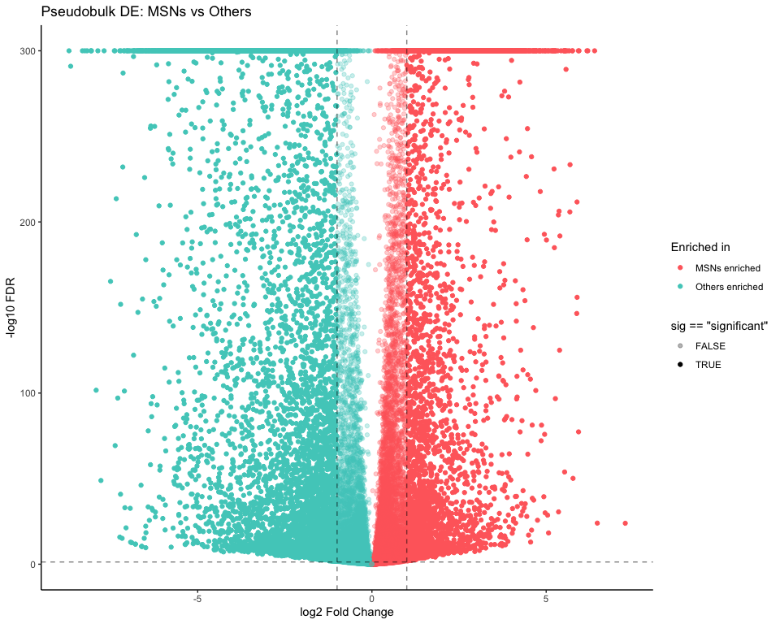

# Highlight top pseudobulk DEGs + epigenetic regulators  
pb_top_labels <- pb_sig %>% arrange(FDR) %>% slice_head(n = 15) %>% pull(gene)  
pb_epi_labels <- intersect(pb_sig$gene, present_epi_genes)  
pb_labels <- union(pb_top_labels, pb_epi_labels)  
  
p_pb_volcano_lab <- p_pb_volcano +  
 geom_text_repel(  
 data = pb_de_results %>% filter(gene %in% pb_labels),  
 aes(label = gene),  
 size = 3, max.overlaps = 50  
 )  
ggsave("MSNvsO_figures/Pseudobulk_Volcano_Plot_highlighted.png", p_pb_volcano_lab, width = 10, height = 8)  
print(p_pb_volcano_lab)

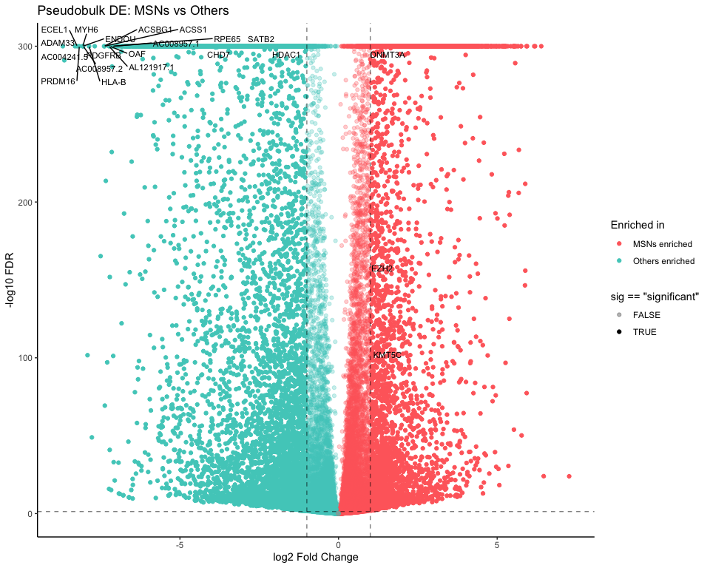

# Epigenetic subset (pseudobulk)  
epi_pb_de_results <- pb_sig %>%  
 filter(gene %in% present_epi_genes) %>% arrange(FDR)  
write.csv(epi_pb_de_results, "MSNvsO_tables/Epigenetic_Regulators_Pseudobulk_DE.csv", row.names = FALSE)  
print(head(epi_pb_de_results, 15))

## gene logFC logCPM LR PValue FDR  
## 1 CHD7 -4.140695 6.589235 23648.3622 0.000000e+00 0.000000e+00  
## 2 SATB2 -3.058797 3.653505 1636.8007 0.000000e+00 0.000000e+00  
## 3 HDAC1 -1.908791 3.867772 1864.7701 0.000000e+00 0.000000e+00  
## 4 DNMT3A 1.819404 8.501984 227129.9126 0.000000e+00 0.000000e+00  
## 5 EZH2 1.105553 3.675989 698.6145 5.983979e-154 2.749781e-153  
## 6 KMT5C 1.275278 2.405097 443.5832 1.797231e-98 6.628300e-98

## GO & KEGG Enrichment for Pseudobulk Significant DE

if (exists("pb_sig") && nrow(pb_sig) >= 10) {  
 cat("Starting GO & KEGG Enrichment (pseudobulk significant)\n")  
  
 pb_genes <- unique(pb_sig$gene)  
 valid_symbols_pb <- pb_genes[pb_genes %in% keys(org.Hs.eg.db, keytype = "SYMBOL")]  
  
 run_go_pb <- function(genes, ontology, labelprefix) {  
 ego <- enrichGO(  
 gene = genes, OrgDb = org.Hs.eg.db, keyType = "SYMBOL",  
 ont = ontology, pAdjustMethod = "BH", pvalueCutoff = 0.05, qvalueCutoff = 0.2  
 )  
 if (is.null(ego) || nrow(as.data.frame(ego)) == 0) return(NULL)  
 out_df <- as.data.frame(ego)  
 write.csv(out_df, file = paste0("MSNvsO_tables/Pseudobulk_GO_Enrichment_", labelprefix, ".csv"), row.names = FALSE)  
  
 p_bar <- barplot(ego, showCategory = 15, title = paste("GO", labelprefix, "(Pseudobulk)"))  
 p_dot <- dotplot(ego, showCategory = 15, title = paste("GO", labelprefix, "(Pseudobulk)"))  
 ggsave(paste0("MSNvsO_figures/Pseudobulk_GO_", labelprefix, "_Barplot.png"), p_bar, width = 12, height = 8)  
 ggsave(paste0("MSNvsO_figures/Pseudobulk_GO_", labelprefix, "_Dotplot.png"), p_dot, width = 12, height = 8)  
 print(p_bar); print(p_dot)  
 invisible(ego)  
 }  
  
 ego_pb_bp <- run_go_pb(valid_symbols_pb, "BP", "Biological_Process")  
 ego_pb_mf <- run_go_pb(valid_symbols_pb, "MF", "Molecular_Function")  
 ego_pb_cc <- run_go_pb(valid_symbols_pb, "CC", "Cellular_Component")  
  
 symbol2entrez_pb <- bitr(valid_symbols_pb, fromType = "SYMBOL", toType = "ENTREZID", OrgDb = org.Hs.eg.db) %>% distinct(SYMBOL, .keep_all = TRUE)  
 if (!is.null(symbol2entrez_pb) && nrow(symbol2entrez_pb) >= 10) {  
 ekegg_pb <- enrichKEGG(gene = symbol2entrez_pb$ENTREZID, organism = "hsa", pvalueCutoff = 0.05)  
 if (!is.null(ekegg_pb) && nrow(as.data.frame(ekegg_pb)) > 0) {  
 kegg_pb_df <- as.data.frame(ekegg_pb)  
 write.csv(kegg_pb_df, "MSNvsO_tables/KEGG_Enrichment_pseudobulk.csv", row.names = FALSE)  
 k_bar_pb <- barplot(ekegg_pb, showCategory = 15, title = "KEGG Pathways (pseudobulk)")  
 k_dot_pb <- dotplot(ekegg_pb, showCategory = 15, title = "KEGG Pathways (pseudobulk)")  
 ggsave("MSNvsO_figures/KEGG_pseudobulk_Barplot.png", k_bar_pb, width = 12, height = 8)  
 ggsave("MSNvsO_figures/KEGG_pseudobulk_Dotplot.png", k_dot_pb, width = 12, height = 8)  
 print(k_bar_pb); print(k_dot_pb)  
 } else {  
 cat("No significant KEGG terms found (pseudobulk)\n")  
 }  
 } else {  
 cat("Too few mappable symbols for KEGG (pseudobulk)\n")  
 }  
} else {  
 cat("No sufficient significant DEs for pseudobulk enrichment\n")  
}

## Starting GO & KEGG Enrichment (pseudobulk significant)

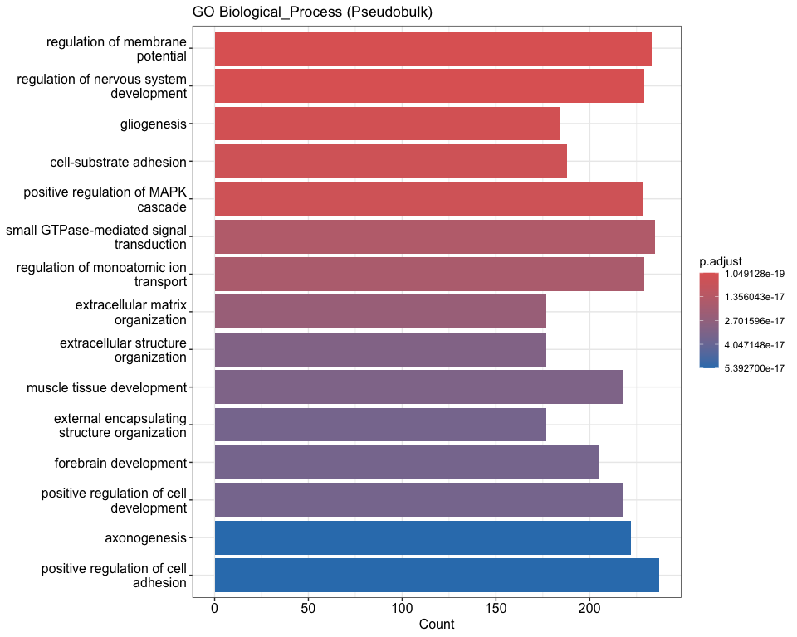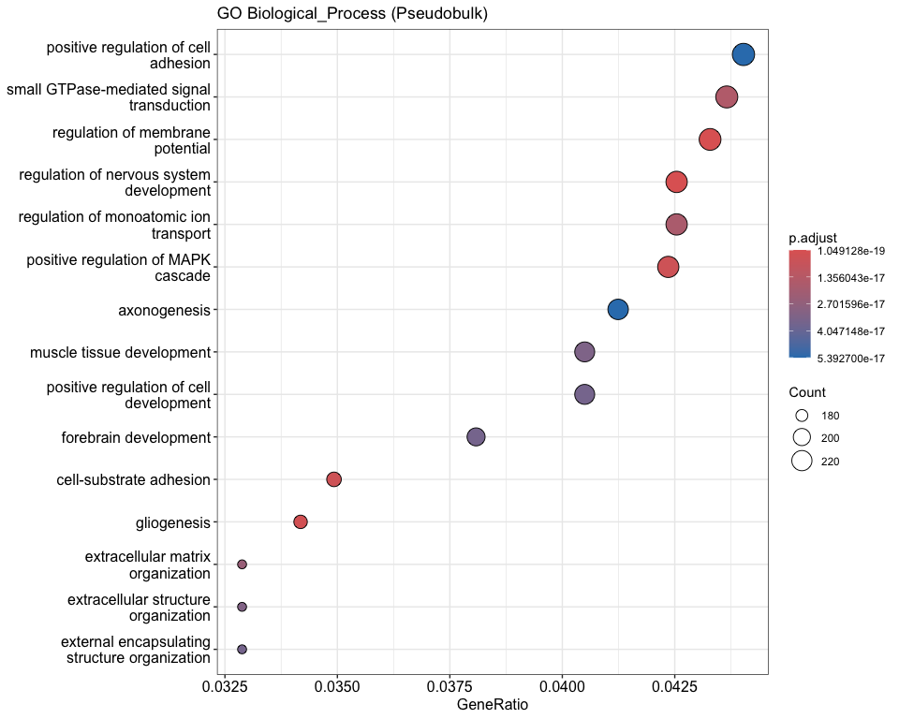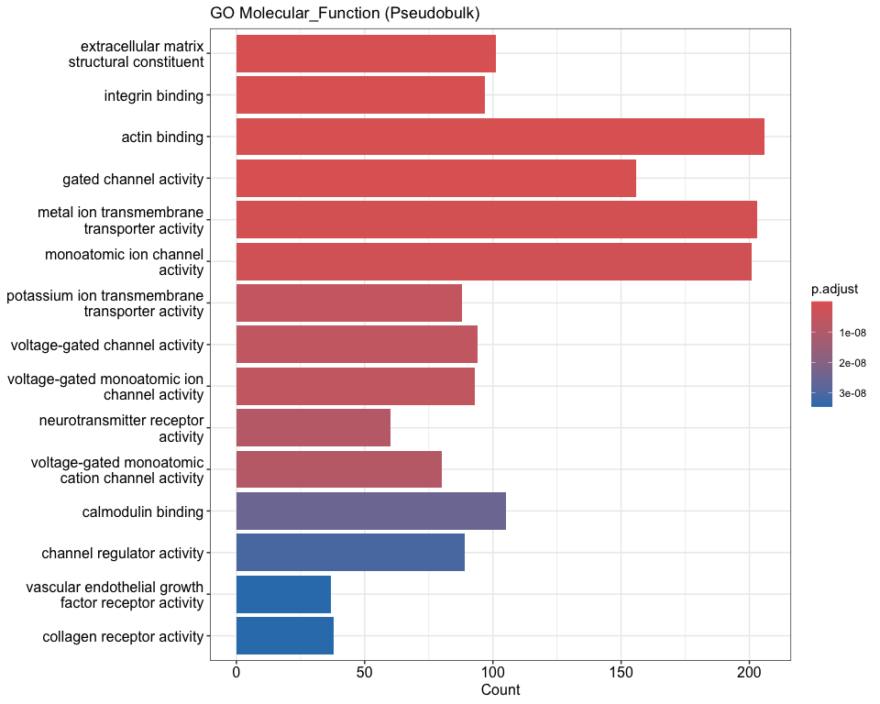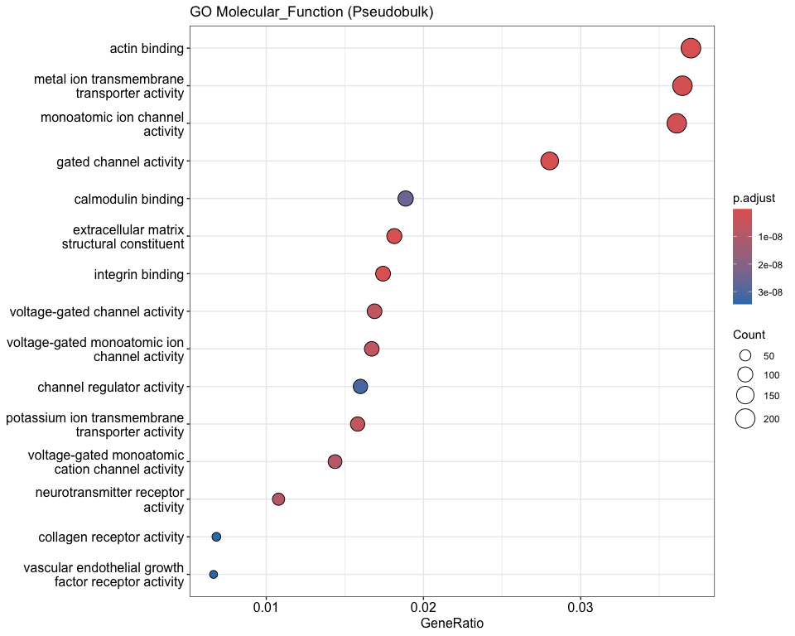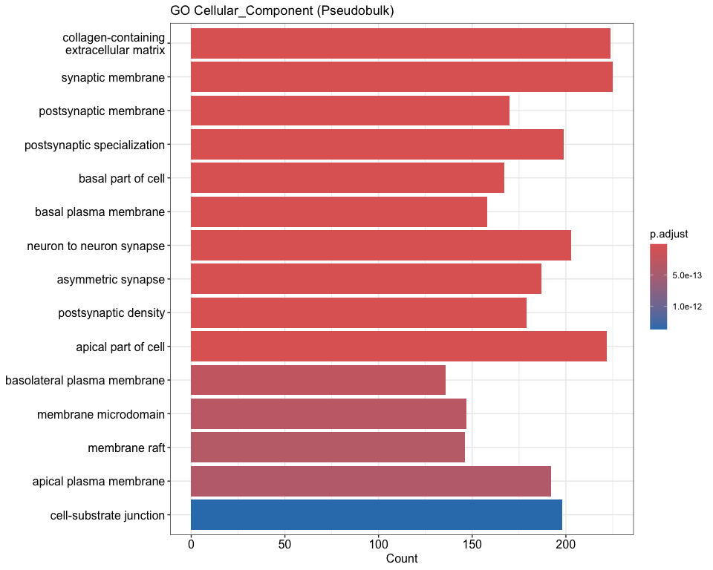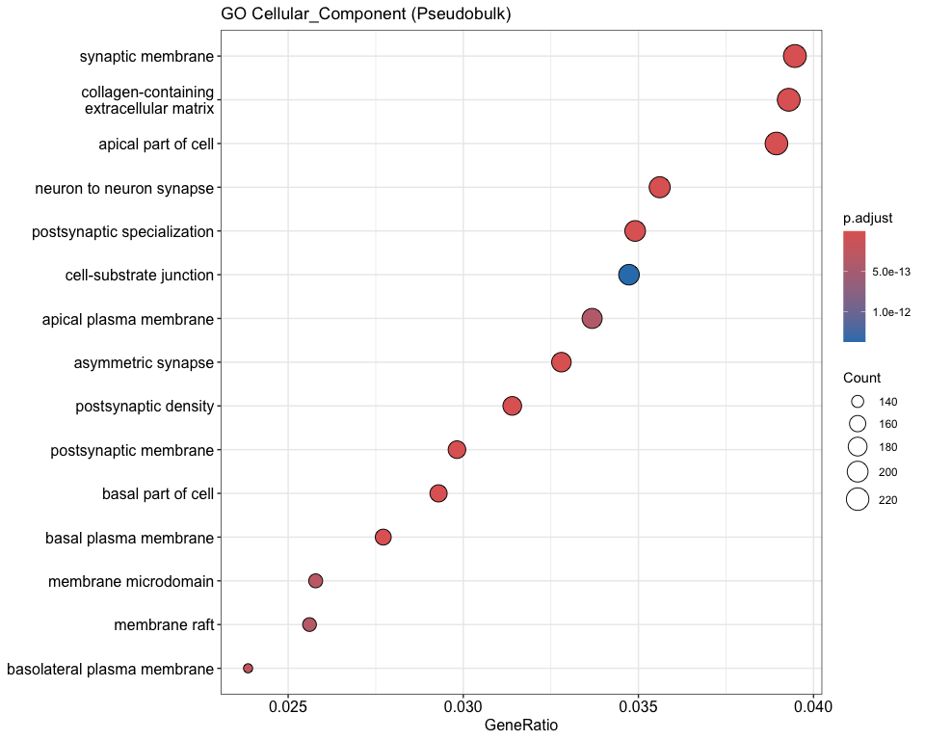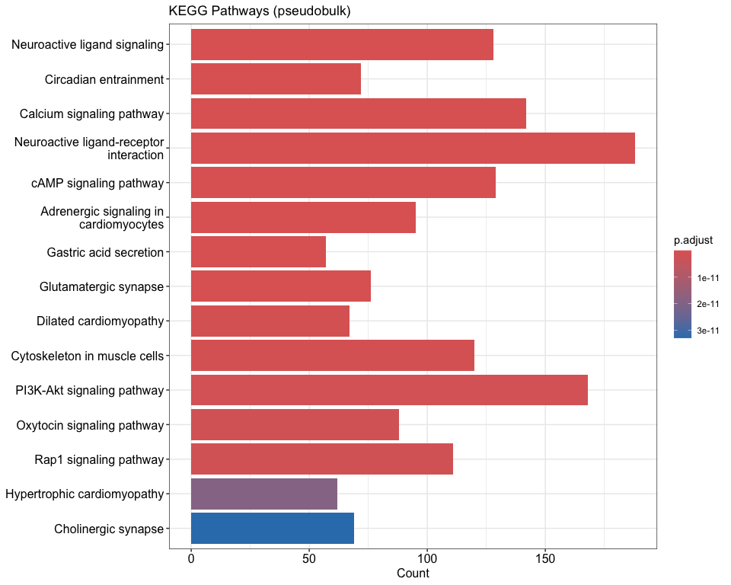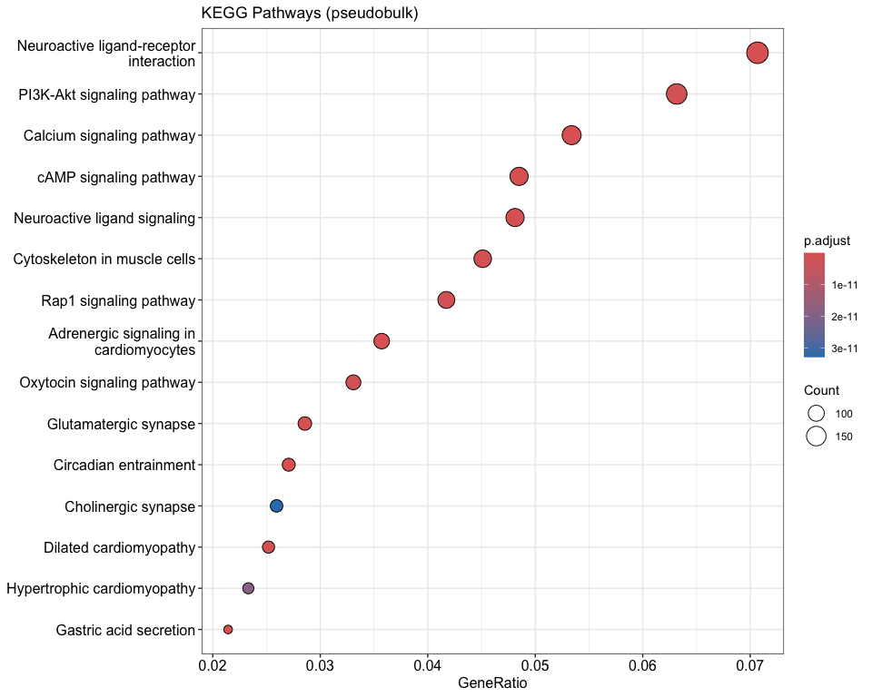

## Enhanced Overlapping DE Analysis: Single-cell vs Pseudobulk

if (exists("markers_msn_vs_others") && exists("pb_de_results")) {  
 sc_genes <- rownames(markers_msn_vs_others)  
 pb_genes <- pb_de_results$gene  
 overlapping_genes <- intersect(sc_genes, pb_genes)  
 cat("Number of overlapping DE genes:", length(overlapping_genes), "\n")  
  
 overlap_sc <- markers_msn_vs_others[overlapping_genes, , drop = FALSE]  
 overlap_pb <- pb_de_results %>% filter(gene %in% overlapping_genes)  
  
 overlap_merged <- merge(  
 overlap_sc %>% dplyr::select(avg_log2FC, p_val_adj) %>%   
 dplyr::rename(sc_log2FC = avg_log2FC, sc_padj = p_val_adj),  
 overlap_pb %>% dplyr::select(gene, logFC, FDR) %>%   
 dplyr::rename(pb_log2FC = logFC, pb_FDR = FDR),  
 by.x = "row.names", by.y = "gene"  
 )  
 colnames(overlap_merged)[1] <- "gene"  
  
 # Calculate agreement metrics  
 overlap_merged$log2fc_correlation <- cor(overlap_merged$sc_log2FC, overlap_merged$pb_log2FC, use = "complete.obs")  
 overlap_merged$direction_agreement <- sign(overlap_merged$sc_log2FC) == sign(overlap_merged$pb_log2FC)  
 overlap_merged$abs_diff <- abs(overlap_merged$pb_log2FC - overlap_merged$sc_log2FC)  
   
 cat("Log2FC Correlation between SC and PB:", round(cor(overlap_merged$sc_log2FC, overlap_merged$pb_log2FC, use = "complete.obs"), 3), "\n")  
 cat("Direction Agreement:", round(mean(overlap_merged$direction_agreement, na.rm = TRUE) * 100, 1), "%\n")  
  
 print(head(overlap_merged[order(overlap_merged$sc_padj + overlap_merged$pb_FDR), ], 10))  
 write.csv(overlap_merged, "MSNvsO_tables/Overlapping_DEGs_SC_vs_PB_enhanced.csv", row.names = FALSE)  
  
 # Enhanced comparison plot  
 p_overlap_enhanced <- ggplot(overlap_merged, aes(x = pb_log2FC, y = sc_log2FC)) +  
 geom_point(aes(color = direction_agreement), alpha = 0.7) +  
 geom_smooth(method = "lm", se = TRUE, color = "red") +  
 geom_abline(intercept = 0, slope = 1, linetype = "dashed", color = "blue") +  
 scale_color_manual(values = c("TRUE" = "darkgreen", "FALSE" = "red"),   
 name = "Direction\nAgreement") +  
 labs(x = "Pseudobulk log2FC", y = "Single-cell log2FC",  
 title = "Overlap: Single-cell vs Pseudobulk DE",  
 subtitle = paste("Correlation: r =",   
 round(cor(overlap_merged$sc_log2FC, overlap_merged$pb_log2FC, use = "complete.obs"), 3))) +  
 theme_classic() +  
 theme(legend.position = "right")  
   
 ggsave("MSNvsO_figures/Enhanced_Overlap_DEGs_Comparison.png", p_overlap_enhanced, width = 12, height = 8)  
 print(p_overlap_enhanced)  
  
 # Identify top disagreements and agreements  
 overlap_merged <- overlap_merged[order(-overlap_merged$abs_diff), ]  
 top_disagreements <- head(overlap_merged, 10)  
   
 top_agreements <- overlap_merged %>%  
 filter(direction_agreement == TRUE) %>%  
 arrange(abs_diff) %>%  
 head(10)  
  
 write.csv(top_disagreements, "MSNvsO_tables/Top_Disagreements_SC_vs_PB.csv", row.names = FALSE)  
 write.csv(top_agreements, "MSNvsO_tables/Top_Agreements_SC_vs_PB.csv", row.names = FALSE)  
  
 cat("Top Disagreements (largest log2FC differences):\n")  
 print(top_disagreements[, c("gene", "sc_log2FC", "pb_log2FC", "abs_diff")])  
   
 cat("Top Agreements (smallest log2FC differences with same direction):\n")  
 print(top_agreements[, c("gene", "sc_log2FC", "pb_log2FC", "abs_diff")])  
} else {  
 cat("One or both DE result objects not found.\n")  
}

## Number of overlapping DE genes: 11156   
## Log2FC Correlation between SC and PB: 0.983   
## Direction Agreement: 82.9 %  
## gene sc_log2FC sc_padj pb_log2FC pb_FDR log2fc_correlation  
## 14 AASS -6.8002640 0 -5.9448029 0 0.983061  
## 16 ABAT 0.6293615 0 0.9982827 0 0.983061  
## 17 ABCA1 -6.1085195 0 -5.2634238 0 0.983061  
## 22 ABCA5 1.0864127 0 0.8370787 0 0.983061  
## 25 ABCA8 -6.9702682 0 -5.6647333 0 0.983061  
## 31 ABCB9 1.4570161 0 1.3820285 0 0.983061  
## 35 ABCC4 1.3708096 0 2.1705123 0 0.983061  
## 36 ABCC5 1.3089314 0 1.2636132 0 0.983061  
## 43 ABCF2P2 2.5553308 0 1.9008083 0 0.983061  
## 46 ABCG2 -5.0689228 0 -4.1046559 0 0.983061  
## direction_agreement abs_diff  
## 14 TRUE 0.85546112  
## 16 TRUE 0.36892118  
## 17 TRUE 0.84509565  
## 22 TRUE 0.24933398  
## 25 TRUE 1.30553486  
## 31 TRUE 0.07498760  
## 35 TRUE 0.79970276  
## 36 TRUE 0.04531815  
## 43 TRUE 0.65452247  
## 46 TRUE 0.96426685

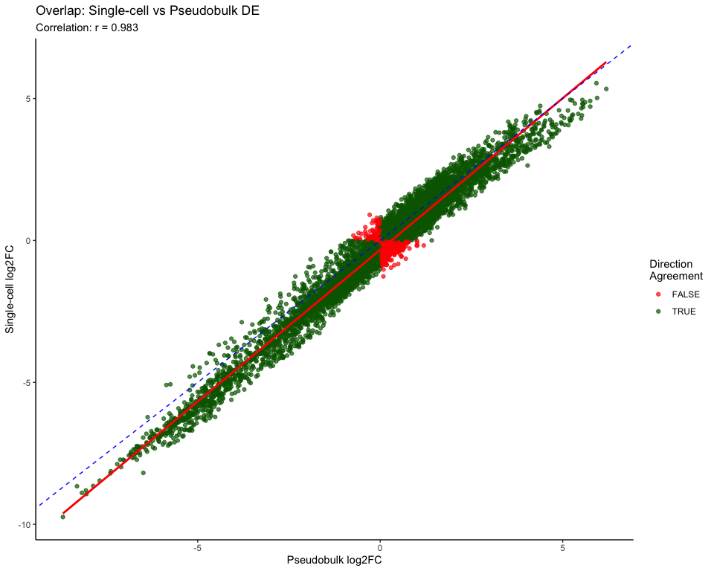

## Top Disagreements (largest log2FC differences):  
## gene sc_log2FC pb_log2FC abs_diff  
## 2747 CNDP1 -8.191471 -6.489389 1.702082  
## 4621 HAPLN2 -6.217557 -4.522281 1.695276  
## 2877 COX7B -3.263674 -1.664117 1.599557  
## 8706 SH3TC2 -6.261379 -4.671924 1.589456  
## 8020 RASGRP3 -6.347349 -4.778904 1.568445  
## 1505 APBB1IP -3.981037 -2.423462 1.557575  
## 8281 RNF220 -6.693554 -5.148115 1.545438  
## 6992 PALD1 -6.175249 -4.630120 1.545129  
## 7402 PLLP -5.615945 -4.077847 1.538099  
## 8573 SELENOW -3.751682 -2.220731 1.530951  
## Top Agreements (smallest log2FC differences with same direction):  
## gene sc_log2FC pb_log2FC abs_diff  
## 1 PIP4K2C 1.6462507 1.6462685 1.785200e-05  
## 2 GOT1 0.3460340 0.3461022 6.827176e-05  
## 3 ZNF783 1.4241233 1.4239750 1.483183e-04  
## 4 PLXNC1 0.1815190 0.1813199 1.990993e-04  
## 5 AC097467.3 0.3727981 0.3730235 2.254108e-04  
## 6 AL049749.1 2.6054694 2.6051090 3.604117e-04  
## 7 POP1 0.4789503 0.4784710 4.793649e-04  
## 8 AC013652.1 1.6066660 1.6061576 5.084068e-04  
## 9 CPA6 -0.2604584 -0.2610448 5.864364e-04  
## 10 SLC24A5 -0.5027310 -0.5021300 6.010146e-04

## Disease Relevance and Therapeutic Target Analysis

cat("Disease Relevance and Therapeutic Target Analysis\n")

## Disease Relevance and Therapeutic Target Analysis

# Define disease-related gene sets (you would normally load these from databases)  
# For demonstration, using some known disease genes  
parkinson_genes <- c("SNCA", "LRRK2", "PARK7", "PINK1", "PRKN", "GBA", "MAPT", "VPS35", "CHCHD2", "DNAJC6")  
huntington_genes <- c("HTT", "HAP1", "HIP1", "CREBBP", "TAF4", "TBP", "CACNA1A", "JPH3", "ATN1", "FMR1")  
alzheimer_genes <- c("APP", "PSEN1", "PSEN2", "APOE", "TREM2", "SORL1", "ABCA7", "BIN1", "CLU", "CR1")  
  
# Combine into neurodegeneration gene set  
neurodegeneration_genes <- unique(c(parkinson_genes, huntington_genes, alzheimer_genes))  
  
# Check overlap with DE genes  
if (exists("sc_sig")) {  
 pd_overlap <- intersect(sc_sig$gene, parkinson_genes)  
 hd_overlap <- intersect(sc_sig$gene, huntington_genes)  
 ad_overlap <- intersect(sc_sig$gene, alzheimer_genes)  
 neuro_overlap <- intersect(sc_sig$gene, neurodegeneration_genes)  
   
 cat("Disease Gene Overlaps with Significant DE genes:\n")  
 cat(paste("Parkinson's:", length(pd_overlap), "genes -", paste(pd_overlap, collapse = ", ")), "\n")  
 cat(paste("Huntington's:", length(hd_overlap), "genes -", paste(hd_overlap, collapse = ", ")), "\n")  
 cat(paste("Alzheimer's:", length(ad_overlap), "genes -", paste(ad_overlap, collapse = ", ")), "\n")  
 cat(paste("Total Neurodegeneration:", length(neuro_overlap), "genes"), "\n")  
   
 # Create disease overlap summary  
 disease_overlap_summary <- data.frame(  
 Disease = c("Parkinson's", "Huntington's", "Alzheimer's", "All Neurodegeneration"),  
 Overlap_Count = c(length(pd_overlap), length(hd_overlap), length(ad_overlap), length(neuro_overlap)),  
 Overlapping_Genes = c(  
 paste(pd_overlap, collapse = ", "),  
 paste(hd_overlap, collapse = ", "),  
 paste(ad_overlap, collapse = ", "),  
 paste(neuro_overlap, collapse = ", ")  
 )  
 )  
   
 write.csv(disease_overlap_summary, "MSNvsO_tables/Disease_Gene_Overlaps.csv", row.names = FALSE)  
 print(disease_overlap_summary)  
}

## Disease Gene Overlaps with Significant DE genes:  
## Parkinson's: 5 genes - SNCA, LRRK2, CHCHD2, PRKN, DNAJC6   
## Huntington's: 3 genes - JPH3, HIP1, FMR1   
## Alzheimer's: 5 genes - APOE, CLU, PSEN2, SORL1, BIN1   
## Total Neurodegeneration: 13 genes   
## Disease Overlap_Count  
## 1 Parkinson's 5  
## 2 Huntington's 3  
## 3 Alzheimer's 5  
## 4 All Neurodegeneration 13  
## Overlapping_Genes  
## 1 SNCA, LRRK2, CHCHD2, PRKN, DNAJC6  
## 2 JPH3, HIP1, FMR1  
## 3 APOE, CLU, PSEN2, SORL1, BIN1  
## 4 SNCA, LRRK2, JPH3, HIP1, APOE, CLU, PSEN2, CHCHD2, PRKN, SORL1, DNAJC6, FMR1, BIN1

# Potential drug targets (genes with known drugs or druggable domains)  
# This is a simplified example - normally you'd use databases like ChEMBL, DrugBank, etc.  
potential_drug_targets <- c("DRD1", "DRD2", "HDAC1", "HDAC2", "HDAC3", "EZH2", "DNMT1", "DNMT3A", "KDM1A")  
  
if (exists("sc_sig")) {  
 drug_target_overlap <- sc_sig %>%  
 filter(gene %in% potential_drug_targets) %>%  
 arrange(p_val_adj)  
   
 if (nrow(drug_target_overlap) > 0) {  
 cat("Significant DE genes that are potential drug targets:\n")  
 print(drug_target_overlap[, c("gene", "avg_log2FC", "p_val_adj")])  
 write.csv(drug_target_overlap, "MSNvsO_tables/Potential_Drug_Targets.csv", row.names = FALSE)  
 }  
}

## Significant DE genes that are potential drug targets:  
## gene avg_log2FC p_val_adj  
## DNMT3A DNMT3A 1.557678 0.000000e+00  
## DRD2 DRD2 4.320890 0.000000e+00  
## DRD1 DRD1 2.764113 0.000000e+00  
## HDAC1 HDAC1 -2.278368 1.214617e-38

## Statistical Improvements and Multiple Testing Correction

cat("Enhanced Statistical Analysis and Global Multiple Testing Correction\n")

## Enhanced Statistical Analysis and Global Multiple Testing Correction

# Collect all p-values from different analyses for global correction  
all_pvalues <- c()  
analysis_source <- c()  
  
if (exists("markers_msn_vs_others")) {  
 all_pvalues <- c(all_pvalues, markers_msn_vs_others$p_val)  
 analysis_source <- c(analysis_source, rep("SingleCell_DE", nrow(markers_msn_vs_others)))  
}  
  
if (exists("pb_de_results")) {  
 all_pvalues <- c(all_pvalues, pb_de_results$PValue)  
 analysis_source <- c(analysis_source, rep("Pseudobulk_DE", nrow(pb_de_results)))  
}  
  
if (exists("ego_bp_all") && !is.null(ego_bp_all)) {  
 ego_bp_df <- as.data.frame(ego_bp_all)  
 if (nrow(ego_bp_df) > 0) {  
 all_pvalues <- c(all_pvalues, ego_bp_df$pvalue)  
 analysis_source <- c(analysis_source, rep("GO_BP", nrow(ego_bp_df)))  
 }  
}  
  
if (exists("ekegg_all") && !is.null(ekegg_all)) {  
 ekegg_df <- as.data.frame(ekegg_all)  
 if (nrow(ekegg_df) > 0) {  
 all_pvalues <- c(all_pvalues, ekegg_df$pvalue)  
 analysis_source <- c(analysis_source, rep("KEGG", nrow(ekegg_df)))  
 }  
}  
  
# Apply global Benjamini-Hochberg correction  
if (length(all_pvalues) > 0) {  
 global_fdr <- p.adjust(all_pvalues, method = "BH")  
   
 # Create summary of global correction impact  
 global_correction_summary <- data.frame(  
 Analysis = analysis_source,  
 Original_P = all_pvalues,  
 Global_FDR = global_fdr,  
 Significant_Original = all_pvalues < 0.05,  
 Significant_Global = global_fdr < 0.05  
 )  
   
 # Count significant tests before and after global correction  
 sig_before <- sum(global_correction_summary$Significant_Original, na.rm = TRUE)  
 sig_after <- sum(global_correction_summary$Significant_Global, na.rm = TRUE)  
   
 cat("Global Multiple Testing Correction Results:\n")  
 cat(paste("Significant tests before global correction:", sig_before), "\n")  
 cat(paste("Significant tests after global correction:", sig_after), "\n")  
 cat(paste("Reduction in significant tests:", sig_before - sig_after,   
 "(", round((sig_before - sig_after)/sig_before * 100, 1), "%)"), "\n")  
   
 write.csv(global_correction_summary, "MSNvsO_tables/Global_Multiple_Testing_Correction.csv", row.names = FALSE)  
   
 # Plot comparison of p-values before and after correction  
 p_global_correction <- ggplot(global_correction_summary, aes(x = -log10(Original_P), y = -log10(Global_FDR))) +  
 geom_point(aes(color = Analysis), alpha = 0.6) +  
 geom_abline(intercept = 0, slope = 1, linetype = "dashed") +  
 labs(x = "-log10(Original P-value)", y = "-log10(Global FDR)",  
 title = "Impact of Global Multiple Testing Correction") +  
 theme_classic()  
   
 ggsave("MSNvsO_figures/Global_Multiple_Testing_Correction.png", p_global_correction, width = 10, height = 8)  
 print(p_global_correction)  
}

## Global Multiple Testing Correction Results:  
## Significant tests before global correction: 35223   
## Significant tests after global correction: 35116   
## Reduction in significant tests: 107 ( 0.3 %)

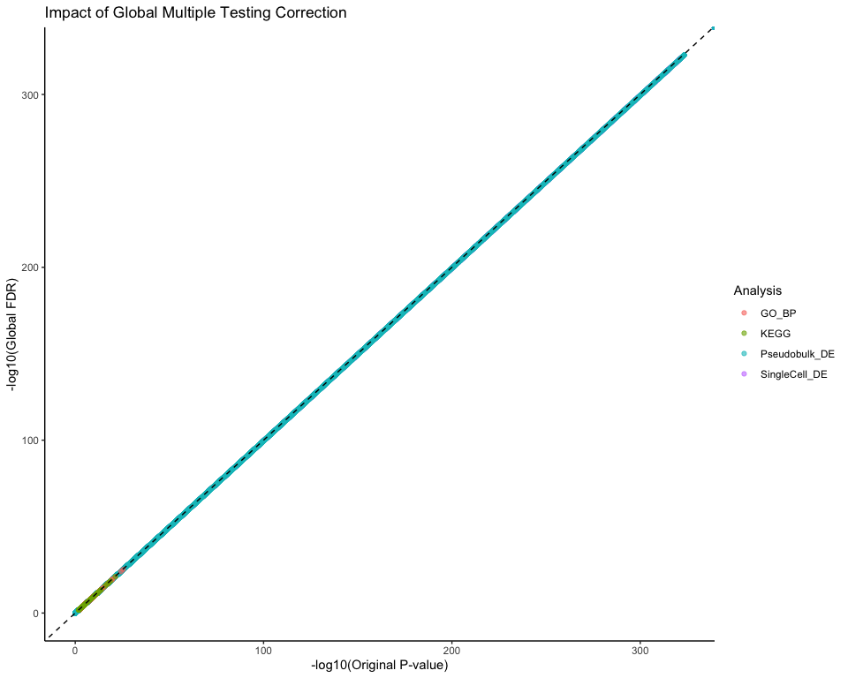

## Advanced Pathway Analysis and Integration

cat("Advanced Pathway Analysis and Integration\n")

## Advanced Pathway Analysis and Integration

# Create pathway-gene network for visualization using GO results  
if (exists("ego_bp_all") && !is.null(ego_bp_all) && nrow(as.data.frame(ego_bp_all)) > 0) {  
 # Get top pathways  
 top_pathways <- as.data.frame(ego_bp_all) %>%  
 filter(p.adjust < 0.05) %>%  
 arrange(p.adjust) %>%  
 slice_head(n = 10)  
   
 if (nrow(top_pathways) > 0) {  
 # Create pathway-gene bipartite network  
 pathway_gene_edges <- c()  
 for (i in 1:nrow(top_pathways)) {  
 pathway_name <- top_pathways$Description[i]  
 # Split gene IDs and get first few genes  
 gene_ids <- unlist(strsplit(top_pathways$geneID[i], "/"))  
   
 for (gene in gene_ids[1:min(5, length(gene_ids))]) { # Limit to top 5 genes per pathway  
 pathway_gene_edges <- rbind(pathway_gene_edges,   
 data.frame(from = pathway_name, to = gene, type = "pathway-gene"))  
 }  
 }  
   
 if (nrow(pathway_gene_edges) > 0) {  
 # Create network  
 pathway_network <- graph_from_data_frame(pathway_gene_edges, directed = FALSE)  
   
 # Set node attributes  
 V(pathway_network)$type <- ifelse(V(pathway_network)$name %in% top_pathways$Description, "pathway", "gene")  
 V(pathway_network)$color <- ifelse(V(pathway_network)$type == "pathway", "#FF6B6B", "#4ECDC4")  
 V(pathway_network)$shape <- ifelse(V(pathway_network)$type == "pathway", "square", "circle")  
   
 # Plot pathway network  
 png("MSNvsO_figures/Pathway_Gene_Network.png", width = 14, height = 12, units = "in", res = 300)  
 plot(pathway_network,  
 vertex.size = ifelse(V(pathway_network)$type == "pathway", 8, 4),  
 vertex.label.cex = 0.7,  
 vertex.label.color = "black",  
 edge.width = 1,  
 layout = layout_with_fr(pathway_network),  
 main = "Top GO Pathways and Associated Genes")  
   
 legend("topright",   
 legend = c("Pathway", "Gene"),   
 fill = c("#FF6B6B", "#4ECDC4"),  
 pch = c(15, 19),  
 title = "Node Type")  
 dev.off()  
 }  
 }  
}

## quartz_off_screen   
## 2

# Pathway enrichment comparison across methods  
enrichment_comparison <- data.frame()  
  
# Add GO enrichment results if they exist  
if (exists("ego_bp_all") && !is.null(ego_bp_all) && nrow(as.data.frame(ego_bp_all)) > 0) {  
 go_bp_df <- as.data.frame(ego_bp_all) %>%  
 slice_head(n = 20) %>%  
 mutate(Method = "GO_BP",   
 Term = Description,  
 Score = -log10(p.adjust))  
 enrichment_comparison <- rbind(enrichment_comparison,   
 go_bp_df[, c("Method", "Term", "Score")])  
}  
  
if (exists("ekegg_all") && !is.null(ekegg_all) && nrow(as.data.frame(ekegg_all)) > 0) {  
 kegg_df <- as.data.frame(ekegg_all) %>%  
 slice_head(n = 20) %>%  
 mutate(Method = "KEGG",  
 Term = Description,  
 Score = -log10(p.adjust))  
 enrichment_comparison <- rbind(enrichment_comparison,  
 kegg_df[, c("Method", "Term", "Score")])  
}  
  
if (nrow(enrichment_comparison) > 0) {  
 # Plot method comparison  
 p_method_comparison <- ggplot(enrichment_comparison, aes(x = reorder(Term, Score), y = Score, fill = Method)) +  
 geom_col(position = "dodge") +  
 coord_flip() +  
 labs(title = "Pathway Enrichment: GO vs KEGG Comparison",  
 x = "Pathway", y = "Enrichment Score (-log10 p.adjust)") +  
 theme_minimal() +  
 theme(axis.text.y = element_text(size = 8))  
   
 ggsave("MSNvsO_figures/Pathway_Method_Comparison.png", p_method_comparison, width = 14, height = 10)  
 print(p_method_comparison)  
}

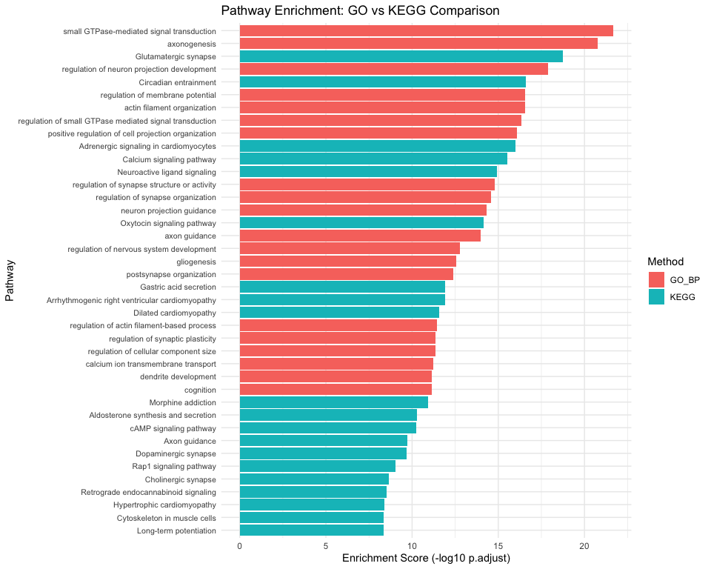

## Tissue Specificity and Conservation Analysis

cat("Tissue Specificity and Evolutionary Analysis\n")

## Tissue Specificity and Evolutionary Analysis

# Brain-specific gene analysis  
# Define brain-specific genes (this would normally come from databases like HPA)  
brain_specific_genes <- c("SYN1", "SYN2", "SNAP25", "VAMP2", "NEUROD1", "NEUROD6",   
 "RBFOX3", "MAP2", "TUBB3", "ENO2", "NCAM1", "GAD1", "GAD2")  
  
# Neuron-specific genes  
neuron_genes <- c("NEFL", "NEFM", "NEFH", "MAP2", "TUBB3", "SYN1", "SNAP25", "CAMK2A")  
  
# Striatum-specific genes   
striatal_genes <- c("DRD1", "DRD2", "PENK", "TAC1", "PPP1R1B", "ARPP21", "RGS9")  
  
if (exists("sc_sig")) {  
 # Check overlap with tissue-specific genes  
 brain_overlap <- intersect(sc_sig$gene, brain_specific_genes)  
 neuron_overlap <- intersect(sc_sig$gene, neuron_genes)  
 striatal_overlap <- intersect(sc_sig$gene, striatal_genes)  
   
 tissue_specificity_summary <- data.frame(  
 Category = c("Brain-specific", "Neuron-specific", "Striatum-specific"),  
 Total_Genes = c(length(brain_specific_genes), length(neuron_genes), length(striatal_genes)),  
 DE_Overlap = c(length(brain_overlap), length(neuron_overlap), length(striatal_overlap)),  
 Overlap_Percent = c(  
 round(length(brain_overlap)/length(brain_specific_genes)*100, 1),  
 round(length(neuron_overlap)/length(neuron_genes)*100, 1),  
 round(length(striatal_overlap)/length(striatal_genes)*100, 1)  
 ),  
 Overlapping_Genes = c(  
 paste(brain_overlap, collapse = ", "),  
 paste(neuron_overlap, collapse = ", "),  
 paste(striatal_overlap, collapse = ", ")  
 )  
 )  
   
 write.csv(tissue_specificity_summary, "MSNvsO_tables/Tissue_Specificity_Analysis.csv", row.names = FALSE)  
 print(tissue_specificity_summary)  
   
 # Visualize tissue specificity  
 p_tissue_spec <- ggplot(tissue_specificity_summary, aes(x = Category, y = Overlap_Percent)) +  
 geom_col(fill = "steelblue", alpha = 0.7) +  
 geom_text(aes(label = paste0(DE_Overlap, "/", Total_Genes)),   
 vjust = -0.5, size = 4) +  
 labs(title = "Tissue Specificity of DE Genes",  
 x = "Gene Category", y = "Percent Overlap with DE genes") +  
 theme_minimal()  
   
 ggsave("MSNvsO_figures/Tissue_Specificity_Analysis.png", p_tissue_spec, width = 10, height = 6)  
 print(p_tissue_spec)  
}

## Category Total_Genes DE_Overlap Overlap_Percent  
## 1 Brain-specific 13 5 38.5  
## 2 Neuron-specific 8 2 25.0  
## 3 Striatum-specific 7 7 100.0  
## Overlapping_Genes  
## 1 RBFOX3, GAD2, SYN2, SNAP25, NCAM1  
## 2 CAMK2A, SNAP25  
## 3 RGS9, ARPP21, PPP1R1B, DRD2, DRD1, TAC1, PENK

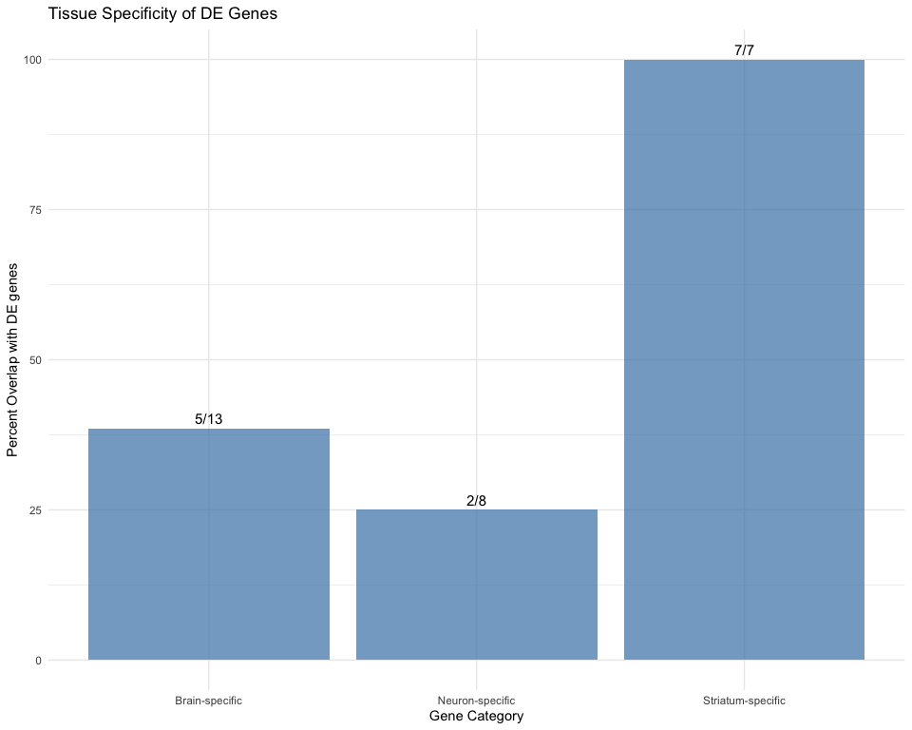

# Evolutionary conservation analysis (simplified)  
# This would normally use phyloP/phastCons scores from UCSC  
# For demonstration, we'll use gene age as a proxy  
essential_genes <- c("ACTB", "GAPDH", "RPL13A", "B2M", "HPRT1") # Housekeeping genes  
primate_specific <- c("ARHGAP11B", "NOTCH2NL") # Known primate-specific genes  
  
if (exists("sc_sig")) {  
 conservation_analysis <- sc_sig %>%  
 mutate(  
 Conservation_Category = case_when(  
 gene %in% essential_genes ~ "Essential/Housekeeping",  
 gene %in% primate_specific ~ "Primate-specific",  
 TRUE ~ "Other"  
 )  
 ) %>%  
 count(Conservation_Category) %>%  
 mutate(Percentage = round(n/sum(n)*100, 1))  
   
 print("Conservation categories of DE genes:")  
 print(conservation_analysis)  
 write.csv(conservation_analysis, "MSNvsO_tables/Conservation_Analysis.csv", row.names = FALSE)  
}

## [1] "Conservation categories of DE genes:"  
## Conservation_Category n Percentage  
## 1 Essential/Housekeeping 3 0.1  
## 2 Other 3840 99.9

## Summary and Enhanced Data Export

cat("Enhanced Analysis Summary\n")

## Enhanced Analysis Summary

# Comprehensive statistics  
analysis_stats <- list()  
analysis_stats$total_cells_original <- ncol(so)  
analysis_stats$total_cells_filtered <- ncol(so_filtered)  
analysis_stats$total_genes_filtered <- nrow(so_filtered)  
analysis_stats$msn_cells <- sum(so_filtered$MSN_vs_Others == "MSNs")  
analysis_stats$other_cells <- sum(so_filtered$MSN_vs_Others == "Others")  
analysis_stats$epigenetic_regulators_detected <- length(present_epi_genes)  
  
if (exists("sc_sig")) {  
 analysis_stats$sc_significant_genes <- nrow(sc_sig)  
 analysis_stats$sc_upregulated_msn <- sum(sc_sig$avg_log2FC > 0)  
 analysis_stats$sc_downregulated_msn <- sum(sc_sig$avg_log2FC < 0)  
}  
  
if (exists("pb_sig")) {  
 analysis_stats$pb_significant_genes <- nrow(pb_sig)  
 analysis_stats$pb_upregulated_msn <- sum(pb_sig$logFC > 0)  
 analysis_stats$pb_downregulated_msn <- sum(pb_sig$logFC < 0)  
}  
  
if (exists("overlap_merged")) {  
 analysis_stats$overlapping_genes <- nrow(overlap_merged)  
 analysis_stats$direction_agreement_percent <- round(mean(overlap_merged$direction_agreement, na.rm = TRUE) * 100, 1)  
}  
  
if (exists("ego_bp_all") && !is.null(ego_bp_all)) {  
 analysis_stats$go_bp_significant_pathways <- nrow(as.data.frame(ego_bp_all))  
}  
  
if (exists("ekegg_all") && !is.null(ekegg_all)) {  
 analysis_stats$kegg_significant_pathways <- nrow(as.data.frame(ekegg_all))  
}  
  
# Convert to data frame for easy viewing  
summary_df <- data.frame(  
 Metric = names(analysis_stats),  
 Value = unlist(analysis_stats),  
 row.names = NULL  
)  
  
print("Comprehensive Analysis Summary:")

## [1] "Comprehensive Analysis Summary:"

print(summary_df)

## Metric Value  
## 1 total_cells_original 63683.0  
## 2 total_cells_filtered 63683.0  
## 3 total_genes_filtered 31258.0  
## 4 msn_cells 16395.0  
## 5 other_cells 47288.0  
## 6 epigenetic_regulators_detected 48.0  
## 7 sc_significant_genes 3843.0  
## 8 sc_upregulated_msn 1742.0  
## 9 sc_downregulated_msn 2101.0  
## 10 pb_significant_genes 10523.0  
## 11 pb_upregulated_msn 4134.0  
## 12 pb_downregulated_msn 6389.0  
## 13 overlapping_genes 11156.0  
## 14 direction_agreement_percent 82.9  
## 15 go_bp_significant_pathways 1087.0  
## 16 kegg_significant_pathways 99.0

write.csv(summary_df, "MSNvsO_tables/Comprehensive_Analysis_Summary.csv", row.names = FALSE)  
  
# Save all key results in a single Excel file with multiple sheets  
if (requireNamespace("openxlsx", quietly = TRUE)) {  
 wb <- openxlsx::createWorkbook()  
   
 # Add summary sheet  
 openxlsx::addWorksheet(wb, "Summary")  
 openxlsx::writeData(wb, "Summary", summary_df)  
   
 # Add DE results  
 if (exists("sc_sig")) {  
 openxlsx::addWorksheet(wb, "SingleCell_DE_Significant")  
 openxlsx::writeData(wb, "SingleCell_DE_Significant", sc_sig)  
 }  
   
 if (exists("pb_sig")) {  
 openxlsx::addWorksheet(wb, "Pseudobulk_DE_Significant")  
 openxlsx::writeData(wb, "Pseudobulk_DE_Significant", pb_sig)  
 }  
   
 # Add epigenetic results  
 if (exists("epi_de_results") && nrow(epi_de_results) > 0) {  
 openxlsx::addWorksheet(wb, "Epigenetic_DE")  
 openxlsx::writeData(wb, "Epigenetic_DE", epi_de_results)  
 }  
   
 # Add overlap results  
 if (exists("overlap_merged")) {  
 openxlsx::addWorksheet(wb, "SC_vs_PB_Overlap")  
 openxlsx::writeData(wb, "SC_vs_PB_Overlap", overlap_merged)  
 }  
   
 # Add GO and KEGG results  
 if (exists("ego_bp_all") && !is.null(ego_bp_all)) {  
 openxlsx::addWorksheet(wb, "GO_BP_Pathways")  
 openxlsx::writeData(wb, "GO_BP_Pathways", as.data.frame(ego_bp_all))  
 }  
   
 if (exists("ekegg_all") && !is.null(ekegg_all)) {  
 openxlsx::addWorksheet(wb, "KEGG_Pathways")   
 openxlsx::writeData(wb, "KEGG_Pathways", as.data.frame(ekegg_all))  
 }  
   
 openxlsx::saveWorkbook(wb, "MSNvsO_tables/Complete_Analysis_Results.xlsx", overwrite = TRUE)  
 cat("All results saved to Complete_Analysis_Results.xlsx\n")  
}

## All results saved to Complete_Analysis_Results.xlsx

# Save processed datasets  
#saveRDS(so, "MSNvsO_tables/Processed_Full_Dataset.rds")  
#saveRDS(so_filtered, "MSNvsO_tables/Filtered_MSN_vs_Others_Dataset.rds")  
  
# Save as .h5Seurat  
#if (requireNamespace("SeuratDisk", quietly = TRUE)) {  
# SeuratDisk::SaveH5Seurat(so_filtered, filename = #"MSNvsO_tables/Filtered_MSN_vs_Others_Dataset.h5Seurat", overwrite = TRUE)  
   
 # Convert to .h5ad (AnnData format)  
# SeuratDisk::Convert("MSNvsO_tables/Filtered_MSN_vs_Others_Dataset.h5Seurat", dest = "h5ad")  
#}  
  
# Create final visualization summary  
cat("Creating Final Summary Visualization\n")

## Creating Final Summary Visualization

# Multi-panel summary figure  
if (exists("sc_sig") && exists("pb_sig")) {  
 # Prepare summary data  
 summary_data <- data.frame(  
 Analysis = c("Single-cell", "Pseudobulk"),  
 Total_DE = c(nrow(sc_sig), nrow(pb_sig)),  
 Upregulated = c(sum(sc_sig$avg_log2FC > 0), sum(pb_sig$logFC > 0)),  
 Downregulated = c(sum(sc_sig$avg_log2FC < 0), sum(pb_sig$logFC < 0))  
 )  
   
 # Reshape for plotting  
 summary_long <- summary_data %>%  
 tidyr::pivot_longer(cols = c("Upregulated", "Downregulated"),   
 names_to = "Direction", values_to = "Count")  
   
 p_summary <- ggplot(summary_long, aes(x = Analysis, y = Count, fill = Direction)) +  
 geom_col(position = "stack") +  
 geom_text(aes(label = Count), position = position_stack(vjust = 0.5)) +  
 scale_fill_manual(values = c("Upregulated" = "#FF6B6B", "Downregulated" = "#4ECDC4")) +  
 labs(title = "Summary of Differential Expression Results",  
 x = "Analysis Method", y = "Number of DE Genes") +  
 theme_minimal()  
   
 ggsave("MSNvsO_figures/Final_Summary_DE.png", p_summary, width = 10, height = 6)  
 print(p_summary)  
}

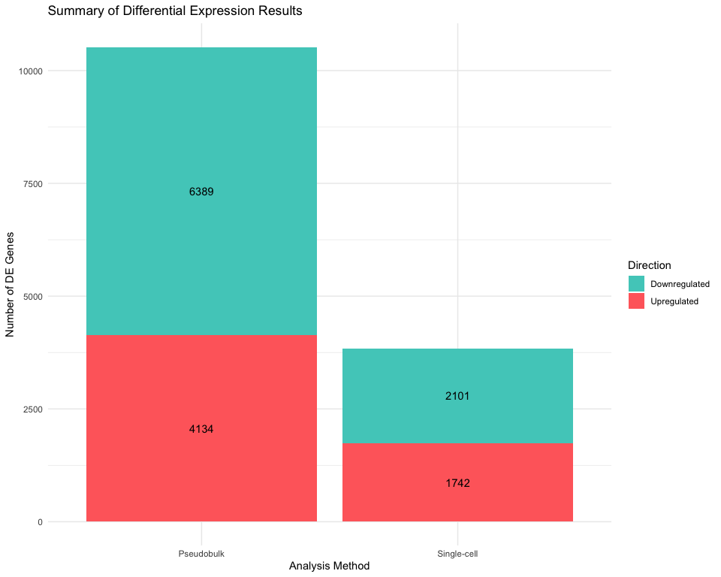

# Final QC check  
cat("\nFinal Quality Check:\n")

##   
## Final Quality Check:

cat(paste("Analysis completed successfully:", Sys.time()), "\n")

## Analysis completed successfully: 2025-08-25 15:43:02.813655

cat(paste("Output files generated in:", getwd()), "\n")

## Output files generated in: /Users/deepak.poduval/Data/Dopamine_Xspecies

cat("Check the 'MSNvsO_figures/' and 'MSNvsO_tables/' directories for all outputs\n")

## Check the 'MSNvsO_figures/' and 'MSNvsO_tables/' directories for all outputs

# List all generated files  
figure_files <- list.files("MSNvsO_figures", full.names = FALSE)  
table_files <- list.files("MSNvsO_tables", full.names = FALSE)  
  
cat("\nGenerated Figures:\n")

##   
## Generated Figures:

for (file in figure_files) cat(paste("-", file), "\n")

## - Cell_Type_Composition.png   
## - D1R_D2R_Classification.png   
## - Dopamine_Markers_FeaturePlot.png   
## - Dopamine_Markers_ViolinPlot.png   
## - Elbow_plot.png   
## - Enhanced_Overlap_DEGs_Comparison.png   
## - Enrichment_Summary.png   
## - Epigenetic_Regulators_DotPlot.png   
## - Epigenetic_Regulators_Enhanced_Heatmap.png   
## - Epigenetic_Regulators_Heatmap.png   
## - Epigenetic_Regulators_ViolinPlot.png   
## - Filtered_Dataset_UMAP.png   
## - Final_Summary_DE.png   
## - Global_Multiple_Testing_Correction.png   
## - GO_Biological_Process_Barplot.png   
## - GO_Biological_Process_Dotplot.png   
## - GO_BP_All_Significant_Barplot.png   
## - GO_BP_All_Significant_Dotplot.png   
## - GO_BP_Downregulated_Barplot.png   
## - GO_BP_Downregulated_Dotplot.png   
## - GO_BP_Upregulated_Barplot.png   
## - GO_BP_Upregulated_Dotplot.png   
## - GO_CC_All_Significant_Barplot.png   
## - GO_CC_All_Significant_Dotplot.png   
## - GO_CC_Downregulated_Barplot.png   
## - GO_CC_Downregulated_Dotplot.png   
## - GO_CC_Upregulated_Barplot.png   
## - GO_CC_Upregulated_Dotplot.png   
## - GO_Cellular_Component_Barplot.png   
## - GO_Cellular_Component_Dotplot.png   
## - GO_MF_All_Significant_Barplot.png   
## - GO_MF_All_Significant_Dotplot.png   
## - GO_MF_Downregulated_Barplot.png   
## - GO_MF_Downregulated_Dotplot.png   
## - GO_MF_Upregulated_Barplot.png   
## - GO_MF_Upregulated_Dotplot.png   
## - GO_Molecular_Function_Barplot.png   
## - GO_Molecular_Function_Dotplot.png   
## - Heatmap_Top_DE_Genes.png   
## - Histone_Writer_Score.png   
## - KEGG_All_Significant_Barplot.png   
## - KEGG_All_Significant_Dotplot.png   
## - KEGG_Downregulated_Barplot.png   
## - KEGG_Downregulated_Dotplot.png   
## - KEGG_pseudobulk_Barplot.png   
## - KEGG_pseudobulk_Dotplot.png   
## - KEGG_singlecell_Barplot.png   
## - KEGG_singlecell_Dotplot.png   
## - KEGG_Upregulated_Barplot.png   
## - KEGG_Upregulated_Dotplot.png   
## - MDS_Sample_Relationships.png   
## - MSN_vs_Others_Classification.png   
## - Overlap_DEGs_log2FC_Comparison_auto_highlighted.png   
## - Pathway_Gene_Network.png   
## - Pathway_Method_Comparison.png   
## - PCA_plot.png   
## - Pseudobulk_GO_Biological_Process_Barplot.png   
## - Pseudobulk_GO_Biological_Process_Dotplot.png   
## - Pseudobulk_GO_Cellular_Component_Barplot.png   
## - Pseudobulk_GO_Cellular_Component_Dotplot.png   
## - Pseudobulk_GO_Molecular_Function_Barplot.png   
## - Pseudobulk_GO_Molecular_Function_Dotplot.png   
## - Pseudobulk_Volcano_Plot_highlighted.png   
## - Pseudobulk_Volcano_Plot.png   
## - QC_scatter_plots.png   
## - QC_violin_plots.png   
## - Tissue_Specificity_Analysis.png   
## - UMAP_CellType.png   
## - Variable_Features.png   
## - Volcano_Plot_MSNs_vs_Others_highlighted.png   
## - Volcano_Plot_MSNs_vs_Others.png   
## - Writer_Eraser_Ratio.png

cat("\nGenerated Tables:\n")

##   
## Generated Tables:

for (file in table_files) cat(paste("-", file), "\n")

## - Cell_Type_Composition.csv   
## - Complete_Analysis_Results.xlsx   
## - Comprehensive_Analysis_Summary.csv   
## - Conservation_Analysis.csv   
## - DE_MSNs_vs_Others_all.csv   
## - DE_MSNs_vs_Others_significant.csv   
## - DE_MSNs_vs_Others.csv   
## - Disease_Gene_Overlaps.csv   
## - Enrichment_Analysis_Summary.csv   
## - Epigenetic_Gene_Categories.csv   
## - Epigenetic_Regulators_DE_singlecell.csv   
## - Epigenetic_Regulators_Pseudobulk_DE.csv   
## - Filtered_MSN_vs_Others_Dataset.h5ad   
## - Filtered_MSN_vs_Others_Dataset.h5Seurat   
## - Filtered_MSN_vs_Others_Dataset.rds   
## - Global_Multiple_Testing_Correction.csv   
## - GO_BP_All_Significant.csv   
## - GO_BP_Downregulated.csv   
## - GO_BP_Upregulated.csv   
## - GO_CC_All_Significant.csv   
## - GO_CC_Downregulated.csv   
## - GO_CC_Upregulated.csv   
## - GO_Enrichment_Biological_Process.csv   
## - GO_Enrichment_Cellular_Component.csv   
## - GO_Enrichment_Molecular_Function.csv   
## - GO_MF_All_Significant.csv   
## - GO_MF_Downregulated.csv   
## - GO_MF_Upregulated.csv   
## - GSEA_GO_Biological_Process.csv   
## - GSEA_GO_Molecular_Function.csv   
## - GSEA_KEGG_Pathways.csv   
## - KEGG_All_Significant.csv   
## - KEGG_Downregulated.csv   
## - KEGG_Enrichment_pseudobulk.csv   
## - KEGG_Enrichment_singlecell.csv   
## - KEGG_Upregulated.csv   
## - Overlapping_DEGs_SC_vs_PB_enhanced.csv   
## - Overlapping_DEGs_SC_vs_PB.csv   
## - Potential_Drug_Targets.csv   
## - Processed_Full_Dataset.rds   
## - Pseudobulk_DE_MSNs_vs_Others_all.csv   
## - Pseudobulk_DE_MSNs_vs_Others_significant.csv   
## - Pseudobulk_GO_Enrichment_Biological_Process.csv   
## - Pseudobulk_GO_Enrichment_Cellular_Component.csv   
## - Pseudobulk_GO_Enrichment_Molecular_Function.csv   
## - QC_Metrics_by_Group.csv   
## - Tissue_Specificity_Analysis.csv   
## - Top_Agreements_SC_vs_PB.csv   
## - Top_Disagreements_SC_vs_PB.csv

cat("\nENHANCED ANALYSIS COMPLETE\n")

##   
## ENHANCED ANALYSIS COMPLETE

cat("This enhanced analysis includes:\n")

## This enhanced analysis includes:

cat("- Comprehensive differential expression analysis\n")

## - Comprehensive differential expression analysis

cat("- GO and KEGG enrichment analysis (ORA)\n")

## - GO and KEGG enrichment analysis (ORA)

cat("- Epigenetic network analysis\n")

## - Epigenetic network analysis

cat("- Disease relevance assessment\n")

## - Disease relevance assessment

cat("- Global multiple testing correction\n")

## - Global multiple testing correction

cat("- Tissue specificity analysis\n")

## - Tissue specificity analysis

cat("- Enhanced statistical comparisons\n")

## - Enhanced statistical comparisons

cat("- Comprehensive result integration\n")

## - Comprehensive result integration

## Session Information

sessionInfo()

## R version 4.5.0 (2025-04-11)  
## Platform: x86_64-apple-darwin20  
## Running under: macOS Sequoia 15.6.1  
##   
## Matrix products: default  
## BLAS: /Library/Frameworks/R.framework/Versions/4.5-x86_64/Resources/lib/libRblas.0.dylib   
## LAPACK: /Library/Frameworks/R.framework/Versions/4.5-x86_64/Resources/lib/libRlapack.dylib; LAPACK version 3.12.1  
##   
## locale:  
## [1] en_US.UTF-8/en_US.UTF-8/en_US.UTF-8/C/en_US.UTF-8/en_US.UTF-8  
##   
## time zone: America/New_York  
## tzcode source: internal  
##   
## attached base packages:  
## [1] grid stats4 stats graphics grDevices utils datasets   
## [8] methods base   
##   
## other attached packages:  
## [1] circlize_0.4.16 ComplexHeatmap_2.24.0 igraph_2.1.4   
## [4] ggrepel_0.9.6 edgeR_4.6.3 limma_3.64.3   
## [7] enrichplot_1.28.2 Matrix_1.7-3 patchwork_1.3.0   
## [10] lubridate_1.9.4 forcats_1.0.0 stringr_1.5.1   
## [13] dplyr_1.1.4 purrr_1.0.4 readr_2.1.5   
## [16] tidyr_1.3.1 tibble_3.2.1 ggplot2_3.5.2   
## [19] tidyverse_2.0.0 org.Hs.eg.db_3.21.0 AnnotationDbi_1.70.0   
## [22] IRanges_2.42.0 S4Vectors_0.46.0 Biobase_2.68.0   
## [25] BiocGenerics_0.54.0 generics_0.1.4 clusterProfiler_4.16.0  
## [28] Seurat_5.3.0 SeuratObject_5.1.0 sp_2.2-0   
##   
## loaded via a namespace (and not attached):  
## [1] fs_1.6.6 matrixStats_1.5.0 spatstat.sparse_3.1-0   
## [4] httr_1.4.7 RColorBrewer_1.1-3 doParallel_1.0.17   
## [7] tools_4.5.0 sctransform_0.4.2 utf8_1.2.5   
## [10] R6_2.6.1 lazyeval_0.2.2 uwot_0.2.3   
## [13] mgcv_1.9-3 GetoptLong_1.0.5 withr_3.0.2   
## [16] gridExtra_2.3 progressr_0.15.1 cli_3.6.5   
## [19] textshaping_1.0.1 spatstat.explore_3.4-3 fastDummies_1.7.5   
## [22] labeling_0.4.3 spatstat.data_3.1-6 ggridges_0.5.6   
## [25] pbapply_1.7-2 systemfonts_1.2.3 yulab.utils_0.2.0   
## [28] gson_0.1.0 DOSE_4.2.0 R.utils_2.13.0   
## [31] dichromat_2.0-0.1 parallelly_1.45.0 rstudioapi_0.17.1   
## [34] RSQLite_2.4.1 gridGraphics_0.5-1 shape_1.4.6.1   
## [37] ica_1.0-3 spatstat.random_3.4-1 zip_2.3.3   
## [40] GO.db_3.21.0 ggbeeswarm_0.7.2 abind_1.4-8   
## [43] R.methodsS3_1.8.2 lifecycle_1.0.4 yaml_2.3.10   
## [46] qvalue_2.40.0 Rtsne_0.17 blob_1.2.4   
## [49] promises_1.3.3 crayon_1.5.3 miniUI_0.1.2   
## [52] ggtangle_0.0.6 lattice_0.22-7 cowplot_1.1.3   
## [55] KEGGREST_1.48.0 pillar_1.10.2 knitr_1.50   
## [58] fgsea_1.34.0 rjson_0.2.23 future.apply_1.11.3   
## [61] codetools_0.2-20 fastmatch_1.1-6 glue_1.8.0   
## [64] ggfun_0.1.8 spatstat.univar_3.1-3 data.table_1.17.4   
## [67] vctrs_0.6.5 png_0.1-8 treeio_1.32.0   
## [70] spam_2.11-1 gtable_0.3.6 cachem_1.1.0   
## [73] openxlsx_4.2.8 xfun_0.52 mime_0.13   
## [76] survival_3.8-3 iterators_1.0.14 statmod_1.5.0   
## [79] fitdistrplus_1.2-2 ROCR_1.0-11 nlme_3.1-168   
## [82] ggtree_3.16.0 bit64_4.6.0-1 RcppAnnoy_0.0.22   
## [85] GenomeInfoDb_1.44.0 irlba_2.3.5.1 vipor_0.4.7   
## [88] KernSmooth_2.23-26 colorspace_2.1-1 DBI_1.2.3   
## [91] ggrastr_1.0.2 tidyselect_1.2.1 bit_4.6.0   
## [94] compiler_4.5.0 plotly_4.10.4 scales_1.4.0   
## [97] lmtest_0.9-40 digest_0.6.37 goftest_1.2-3   
## [100] presto_1.0.0 spatstat.utils_3.1-4 rmarkdown_2.29   
## [103] XVector_0.48.0 htmltools_0.5.8.1 pkgconfig_2.0.3   
## [106] fastmap_1.2.0 rlang_1.1.6 GlobalOptions_0.1.2   
## [109] htmlwidgets_1.6.4 UCSC.utils_1.4.0 shiny_1.10.0   
## [112] farver_2.1.2 zoo_1.8-14 jsonlite_2.0.0   
## [115] BiocParallel_1.42.1 GOSemSim_2.34.0 R.oo_1.27.1   
## [118] magrittr_2.0.3 GenomeInfoDbData_1.2.14 ggplotify_0.1.2   
## [121] dotCall64_1.2 Rcpp_1.0.14 ape_5.8-1   
## [124] reticulate_1.42.0 stringi_1.8.7 MASS_7.3-65   
## [127] plyr_1.8.9 parallel_4.5.0 listenv_0.9.1   
## [130] deldir_2.0-4 Biostrings_2.76.0 splines_4.5.0   
## [133] tensor_1.5 hms_1.1.3 locfit_1.5-9.12   
## [136] spatstat.geom_3.4-1 RcppHNSW_0.6.0 reshape2_1.4.4   
## [139] evaluate_1.0.3 tzdb_0.5.0 foreach_1.5.2   
## [142] httpuv_1.6.16 RANN_2.6.2 polyclip_1.10-7   
## [145] future_1.58.0 clue_0.3-66 scattermore_1.2   
## [148] xtable_1.8-4 RSpectra_0.16-2 tidytree_0.4.6   
## [151] later_1.4.2 viridisLite_0.4.2 ragg_1.4.0   
## [154] aplot_0.2.6 memoise_2.0.1 beeswarm_0.4.0   
## [157] cluster_2.1.8.1 timechange_0.3.0 globals_0.18.0